THE INFLUENCE OF MOTHERS' KNOWLEDGE TOWARDS
THEIR PERCEIVED BEHAVIORAL CONTROL

Tiara Putri Amelia^{1*}, Amanda Bunga Gracia² , Rita Destiwati³
^{1,2,3} Communicaiton Science, Telkom University, Bandung, Indonesia
* tiaraputriamelia2002@gmail.com

Artikel  Submitted: xx-xx-20xx  Reviewed: xx-xx-20xx  Accepted: xx-xx- 20xx  Published: xx-xx-20xx  DOI: https://doi.org/10.32509/_diisi pengelola jurnal  This work is licensed under a Creative Commons Attribution-NonCommercial-ShareAlike 4.0.  Volume :  No. :  Bulan :  Tahun :  Halaman : | Abstract  This research explores the environmental impact of baby formula production and its influence on breastfeeding rates, particularly in Asia. It highlights the role of the Breastfeeding Mother Community on Facebook in raising awareness among mothers, despite a lack of content on the environmental drawbacks of formula milk. The study aims to assess community members’ knowledge of these impacts and its effect on their behavior. Using the Theory of Planned Behavior, it investigates the link between environmental knowledge and perceived behavioral control. The research uses a quantitative approach, use questionnaires, with a sample of 400 respondents from the community. This research employs various data analysis techniques, including descriptive analysis, normality test, simple linear regression analysis, hypothesis testing, and the coefficient of determination test. The findings reveal that the knowledge of the Breastfeeding Mother Community members on Facebook about the environmental impact of formula milk production influences their perceived behavioral control by 28.2%. The remaining percentage is influenced by variables not covered in this research. However, the results indicate no significant influence, as evidenced by the calculated T value being greater than the T table (-4.742 < 1.965), leading to the rejection of H1 and acceptance of H0.  Keywords: negative impact of baby formula milk production; environmental pollution; knowledge  Abstrak  Penelitian ini mengeksplorasi dampak lingkungan dari produksi susu formula bayi dan pengaruhnya terhadap tingkat menyusui, terutama di Asia. Penelitian ini menyoroti peran Komunitas Ibu Menyusui di Facebook dalam meningkatkan kesadaran di antara ibu, meskipun kurangnya konten tentang kerugian lingkungan dari susu formula. Studi ini bertujuan untuk menilai pengetahuan anggota komunitas tentang dampak ini dan efeknya terhadap perilaku mereka. Menggunakan Teori Perilaku Terencana, penelitian ini menyelidiki hubungan antara pengetahuan lingkungan dan kontrol perilaku yang dirasakan. Penelitian ini menggunakan pendekatan kuantitatif, menggunakan kuesioner, dengan sampel 400 responden dari komunitas. Penelitian ini menggunakan berbagai teknik analisis data, termasuk analisis deskriptif, uji normalitas, analisis regresi linier sederhana, pengujian hipotesis, dan uji koefisien determinasi. Temuan menunjukkan bahwa pengetahuan anggota Komunitas Ibu Menyusui di Facebook tentang dampak lingkungan produksi susu formula bayi mempengaruhi kontrol perilaku yang dirasakan mereka sebesar 28,2%. Persentase yang tersisa dipengaruhi oleh variabel yang tidak dicakup dalam penelitian ini. Namun, hasilnya menunjukkan tidak ada pengaruh yang signifikan, seperti yang dibuktikan oleh nilai T yang dihitung lebih besar dari tabel T (-4,742 < 1,965), yang mengarah pada penolakan H1 dan penerimaan H0.  Kata Kunci: Dampak negatif produksi susu formula bayi; Pencemaran lingkungan; Pengetahuan
INTRODUCTION
Formula milk as a common substitute for breast milk due to various factors such as health issues, restricted working hours, demanding lifestyle, inadequate breast milk production, or personal choice (Merry et al., 2023). However, it highlights the significant environmental impacts of formula milk production, including plastic waste, carbon emissions, and environmental pollution, with the production process generating various types of waste (Wagini et al., 2002). Alarming statistics about waste management in Indonesia, with 34.29% of the national waste stockpiles being unmanaged in 2022 (SIPSN, 2023). It further emphasizes the environmental cost of formula milk production, stating that the production of one kilogram of infant formula releases 4 kilograms of carbon dioxide (CO2), a greenhouse gas that harms the environment (Smith, 2019).
The increasing levels of carbon dioxide, largely due to formula milk factories, contributing to soil degradation and greenhouse gas emissions, leading to decreased soil fertility, erosion, and other environmental problems (Mahcene et al., 2019). These negative impacts contribute to global warming, an ecological disruption on Earth caused by the ongoing rise in the average temperature of the Earth’s atmosphere, oceans, and land (Utina, 2008). The drastic fall in breastfeeding rates in Asia, with millions of babies worldwide now consuming formula milk (Smith, 2019). In Indonesia, only 52.5% of the 2.3 million infants under six months old are breastfed, marking a 12 percent decline from 2019 statistics (RISKESDAS, 2021). Five provinces in Indonesia in 2021 had the highest spending on formula milk: West Java, East Java, North Sumatra, Central Java, and Banten (Kompas, 2022). This underscores the need for the Indonesian Breastfeeding Mother Community to share breastfeeding tips and discourage the use of formula milk as a substitute for breast milk.
The significant correlation between increased milk production levels and a prevalent trend of formula milk consumption in the community, indicating a substantial preference for formula milk but also raising concerns about potential environmental consequences (Setiawan & Setyawati, 2020). The importance of addressing these sustainability challenges by raising awareness about the environmental impact of everyday consumption choices, endorsing sustainable agricultural practices, and advocating for eco-friendly solutions (Hidayah, 2015). Even though the consumption of formula milk has become a sustainability challenge, the existence of a community of breastfeeding mothers can play an important role and help reduce the negative impact of this sustainable consumption of formula milk. The Indonesian Breastfeeding Mothers Community, with many active followers reaching 165 thousand on the Facebook platform, has become a valuable center of interaction for mothers who share experiences, receive positive support, and receive important education about breastfeeding. Despite providing positive support for breastfeeding, it is observed that education regarding the negative impacts of formula milk production on the environment still lacks depth, even though conveying this information is important for collective awareness.
The theoretical foundation of this research is based on the concept of knowledge as presented by Wahana (2016) They emphasize the importance of knowledge as the fundamental basis for understanding the development and interactions of individuals, societies, and civilizations with their environment. Knowledge, in this context, extends beyond mere information and facts; it involves a profound understanding of how this information is interconnected and applicable within specific contexts. Applying this concept to maternal knowledge about formula milk production and its negative impacts, such as carbon dioxide emissions and plastic waste, becomes crucial. Informed mothers, with a deeper understanding of the consequences of formula milk production on the environment, can make more environmentally conscious choices. Based on Bloom’s division of domains in Notoatmodjo (2010), knowledge is broadly divided into six levels: Know, Understanding (comprehension), Application, Analysis, Synthesis, and Evaluation. Each level represents a different depth and type of knowledge, from simple recall of information to the ability to justify or assess a particular object based on self-determined criteria or societal norms. This framework provides a comprehensive understanding of the dimensions of knowledge.
Knowledge measurement in this research is typically conducted through interviews or questionnaires that inquire about the content of the material being assessed from the research subjects. Budiman & Riyanto, (2013) propose a framework for evaluating an individual’s knowledge based on different stages, including knowing and understanding, application and analysis, and synthesis, analysis, and evaluation. Perceived Behavioral Control, as defined by Hendriawan & Ghina, (2016) is the control of individual behavior regarding the perception of how easy or difficult it is to perform an action, which is a reflection of experience and a form of anticipation of the action. According to Ajzen & Fishbein (1977), perceived behavioral control is how an individual perceives their ability to influence or manage a situation describing behavior. It is a description of past experiences and a form of anticipation of an obstacle. In this study, perceived behavioral control can be used as an influenced variable, reflecting past experience and anticipation of obstacles that may occur. This control can be seen in a mother’s habit of giving formula milk to her baby, which can be influenced by her past experience and information from someone as the basis of her knowledge. The community of social media that the researcher raised should be able to be one of the controls of a mother’s behavior in giving formula milk. To measure perceptions about perceived behavioral control, indicators such as control of belief strength and perceived power are used.
The Theory of Planned Behavior (TPB), developed from the Theory of Reasoned Action model by Ajzen in 1988, incorporates Perceived Behavior Control and predicts behavior that can be considered and planned (Nuary, 2010). According Wellington stated in Nuary (2010) The TPB is advantageous over other behavioral theories as it can identify a person’s belief in control over outcomes, distinguishing between desired and undesired behavior. The theory posits that a person’s behavior can influence intentions and perceived behavioral control, while intentions themselves influence attitudes, subjective norms, and perceived behavioral control (Santoso, 2018).

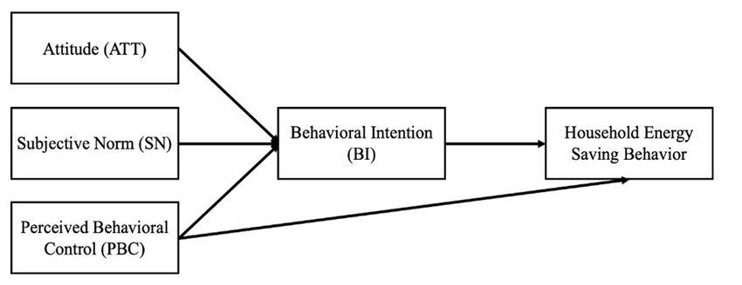
Picture 1. Theory of Planned Behavior
(Source: TPB book by Martin Fishbein and Icek Ajzen, 1977)

The TPB guides human actions through three types of beliefs: Behavioral beliefs, Normative beliefs, and Control beliefs. These beliefs are related to attitude, subjective norms, and perceived behavioral control respectively. The TPB explains that attitudes towards behavior, subjective norms, and perceived behavioral control can impact behavioral intention variables, which in turn will influence the behavioral variable (Ajzen & Fishbein, 1977)
In this research, the author used the same variables and dimensions as previous studies such as those by Purusottama (2019), Purwanto et al. (2023), Pratama & JAR (2020), Mawardani et al. (2023) and Mardikaningsih (2019). These studies discuss similar themes and variables, and talk about the influence on someone’s decision. The author also referenced international journals that highlight several negative impacts, including carbon dioxide (CO2) emissions, as shown in (Smith, 2019). The research uses the same theory as the author, namely the Theory of Planned Behavior (TPB), even though the research objects are different. The author also uses the research of Alsahafi & Cheng (2016) as they have the same variables and dimensions. This research is distinguished from the previous study by a more focused exploration of how maternal knowledge influences perceived behavioral control regarding the negative environmental impacts of formula milk production.
This study employs a research framework, a systematic strategy and set of guidelines for conducting research projects, to organize the work and ensure the validity and reliability of the findings. The independent variables under study are knowledge and a mother’s perceived behavioral control, which is the dependent variable. The research aims to understand the role of knowledge in influencing perceived behavioral control, based on the Theory of Planned Behavior (TPB). The researcher believes that knowledge is fundamental, with most knowledge indicators being background factors in the TPB theory. Therefore, this research conceptually underpins knowledge as a strong factor that can influence a mother’s control over her behavior based on the information they gather as a source of knowledge.
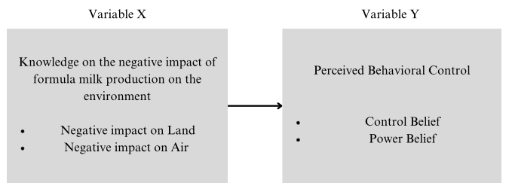
Picture 2. Research Framework

The research hypotheses, as per Crano et al. (2023), are empirical specifications of the conceptual hypothesis and can be seen as predictions about what will be observed in the study. The null hypothesis (H0) posits that there is no influence of mothers’ knowledge on their perceived behavioral control regarding the negative impact of formula milk production on the environment. The alternative hypothesis (H1) suggests that there is a positive influence between mothers’ knowledge about the negative impact of formula milk production on the environment and the level of perceived behavioral control. These hypotheses are based on the assumption that the higher the mothers’ knowledge about the negative impact of formula milk production on the environment, the higher the level of perceived behavioral control. The scope of this research focuses on the knowledge of the members of the Indonesian Breastfeeding Mother Community on Facebook regarding the negative effects of formula milk production on the environment and how this knowledge influences their behavioral intentions, which are mediated by perceived behavioral control.

METHODOLOGY
This research employed a quantitative method, which measures behavior, knowledge, and opinions, using numbers derived from data analysis. The study had descriptive and causal objectives, aiming to provide an objective picture of the situation and understand the relationship between variables. The research investigation was correlational, examining the relationship between variables related to a problem. The research was a field study, with no intervention in the data, and used a cross-sectional approach, collecting data within a single period, followed by processing, analysis, and conclusion drawing.
Table 1. Research Characteristics

No | Research Characteristics | Type
1 | Method | Quantitative
2 | Objective | Descriptive
3 | Type of Investigation | Casual
4 | Researcher Involvement | Does not interfere with data
5 | Unit of Analysis | Individual
6 | Execution Time | Cross Selection
7 | Research Model | TPB
Source: Indrawati, 2015

The operationalization of variables involved techniques and methods to measure and dissect the variables into components. The research focused on two variables: the knowledge of the negative impact of formula milk production on the environment (independent variable) and the Mother’s Perceived Behavioral Control (dependent variable). The operationalization process involved assigning categories or delineating data characteristics within the study, facilitating the measurement of these variables. The research produced several dimensions and indicators from these two variables. This research utilized a quantitative method with an ordinal scale to measure behavior, knowledge, and opinions. The data was measured using a Likert scale, which gauges the attitudes, viewpoints, and perspectives of individuals or groups in relation to social phenomena. Respondents indicated their level of agreement or disagreement with each question or statement, with each statement in the questionnaire having five answers with a score of 1 to 5. The Likert scale was chosen for its ease of use, flexibility in measuring opinion intensity, and efficiency in data collection and analysis.
The population of this study was the members of the Indonesian Breastfeeding Mother Community on Facebook, with 165 thousand members. The research aimed to understand the community’s knowledge regarding the negative effects of formula milk production on the environment and how this knowledge influences their behavioral intentions, mediated by perceived behavioral control. The sample, a subset of the population, consisted of members of the Indonesian Breastfeeding Mother Community on Facebook. The sample size was calculated using the Slovin formula, resulting in approximately 400 respondents. The researchers employed a non-probability sampling methodology, specifically Purposive Sampling, which is based on certain criteria. In this case, the sample was limited to female respondents who are members of the Indonesian breastfeeding mother community on Facebook.
The research employed a systematic data collection process, as described by Taherdoost, (2021), using Google Forms due to its ease of use, flexibility, and efficient data management. Primary data, defined by Hardani et al (2020) as information directly obtained from the source, was collected through a questionnaire distributed to respondents via social media. The questionnaire was designed in three parts: screening questions, demographic characteristics, and statements related to the research variables. Secondary data, characterized as previously collected or generated information obtained indirectly Hardani et al., (2020), was sourced from literature studies, reputable journals, scientific publications, previous research, book references, and other relevant written works. Government-owned written sources were also utilized.
A validity test, which is an examination of the precision of a measurement instrument Jaya (2020) was conducted in this research. The test aimed to determine the extent to which a measurement instrument could carry out measurements (Abdullah, 2015). The validity of the questionnaire items was determined by comparing the observed correlation coefficient (r count) with the critical table value (r table). A pretest was conducted with a sample of around 30 people (Sugiyono & Lestari, 2021). to carry out validity and reliability tests. The validity test was carried out using product moment correlation, and data collection analysis was conducted using the SPSS 25 software package. The research also conducted a reliability test to evaluate the stability and consistency of a measuring instrument (Jaya, 2020). The reliability of the questionnaire items was determined by the Cronbach’s Alpha reliability coefficient. If the Cronbach’s Alpha value for a questionnaire is greater than 0.60, the questionnaire is considered reliable. The reliability test results obtained for variable X and Y were 0.829 and 0.889 respectively, indicating that the instruments for both variables were reliable.
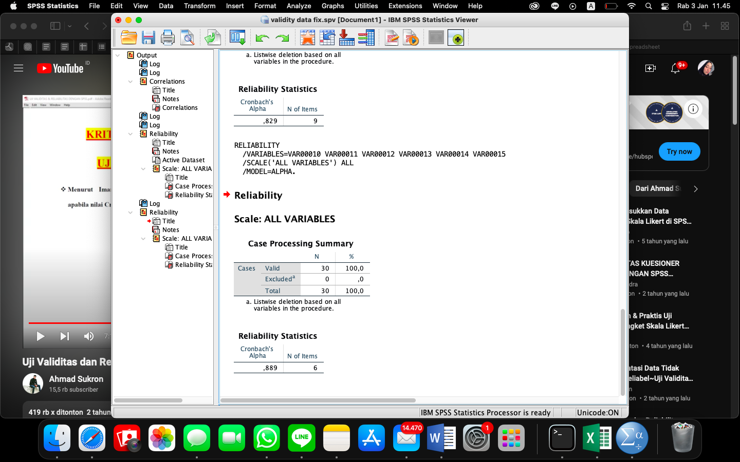
Picture 3. Reliability Variable (X) Test
Picture 4. Reliability Variable (Y) Test
The research utilized descriptive techniques for data analysis, which are used to examine data rather than draw conclusions from it (Sugiyono & Lestari, 2021). The scores for each statement were added to determine a cumulative grade, and the percentage was calculated by dividing the cumulative value by the frequency value and multiplying the result by 100. The normality test was conducted using IBM SPSS 25 software with the Kolmogorov-Smirnov normality test to ascertain whether confounding variables within the regression model exhibit a normal distribution. The research employed correlation analysis to assess the degree of the linear association between two variables and calculate their relationship strength (Miot, 2018). The correlation value ranges from 0 to 1 or 0 to -1, with the direction of the relationship indicated by positive and negative signs.
Data from the research’s simple linear regression examination were used to determine how independent factors influence the dependent variable. Hypothesis testing, a systematic process for determining whether the findings of a research study align with a specific theory that applies to a population Turner, M. (2023) was conducted to test whether there is a positive influence on variable X on variable Y. The test was carried out with an error rate of 5%, using the T-test for hypothesis testing criteria. The coefficient of determination test was employed to ascertain the magnitude of the influence of the relationship. The values of this coefficient of determination range from 0 to 1. When R² is close to 0, it suggests that the variable has little to no influence. Conversely, when R² is approaching 1, it indicates a significant influence between the independent variable and the dependent variable.

RESULT AND DISCUSSION
This research utilized a questionnaire distributed via Google Form to members of the Indonesian Breastfeeding Mother Community on Facebook. The questionnaire was divided into several sections. The first section screened respondents to confirm their membership in the community. The following sections contained statements related to two variables: (X) Knowledge of the negative impact of formula milk production on the environment, and (Y) Perceived Behavioral Control. Variable X was further divided into two dimensions: Negative Impact on Land and Negative Impact on Air, with respective indicators of plastic waste and Carbon CO2. Variable Y was divided into Control Belief and Power Belief dimensions, with respective indicators of Steps on Minimizing Consumption and Affecting Other People/Mothers’ Perception. The final section collected respondent identity information. The research aimed to understand the community’s awareness of the environmental impact of formula milk and their perceived control over minimizing consumption.
Table 2. Respondents' Responses to Variable (X)
Dimensions | Indicators | Statement |  | Response |  |  |  |  | Total Score | % | Category
Dimensions | Indicators |  |  | CD | SD | N | SA | CA | Total Score | % | Category
Negative Impact on Land | Plastic Waste | 1 | I know that plastic waste from baby formula factories is one of the largest contributors to the industry. | 93 | 122 | 43 | 96 | 46 | 1086 | 54 | Medium
Negative Impact on Land | Plastic Waste | 2 | I know that plastic waste is generated in the production and distribution of the baby formula I use. | 87 | 109 | 76 | 71 | 57 | 1111 | 56 | Medium
Negative Impact on Land | Plastic Waste | 3 | I know that plastic waste originating from baby formula factories does not decompose in landfills. | 82 | 118 | 75 | 70 | 55 | 1108 | 55 | Medium
Negative Impact on Land | Plastic Waste | 4 | I know that plastic waste from baby formula factories can pollute the environment. | 53 | 120 | 86 | 97 | 44 | 1168 | 58 | Medium
Negative Impact on Land | Plastic Waste | 5 | I know that soil pollution occurs due to plastic waste from baby formula factories. | 85 | 102 | 86 | 74 | 53 | 1116 | 56 | Medium
Negative Impact on Land |  |  |  |  |  |  |  |  |  | 56 | Medium
Negative Impact on Air | Carbon CO2 | 1 | I know that carbon dioxide (CO2) is produced in the production and distribution of the baby formula I use. | 58 | 122 | 87 | 54 | 79 | 1184 | 59 | Medium
Negative Impact on Air | Carbon CO2 | 2 | I know the dangers of carbon dioxide and its potential to harm the environment. | 63 | 105 | 88 | 95 | 45 | 1169 | 59 | Medium
Negative Impact on Air | Carbon CO2 | 3 | I know that carbon dioxide from baby formula factories can contribute to global warming. | 87 | 103 | 89 | 75 | 46 | 1097 | 55 | Medium
Negative Impact on Air | Carbon CO2 | 4 | I know that greenhouse gas emissions from dairy factories can cause climate change. | 81 | 122 | 65 | 84 | 48 | 1106 | 55 | Medium
Negative Impact on Air |  |  |  |  |  |  |  |  |  | 57 | Medium
Average Score |  |  |  |  |  |  |  |  |  | 56,5 | Medium
The following is the continuum line for the variable Knowledge on the negative impact of formula milk production on the environment (X):
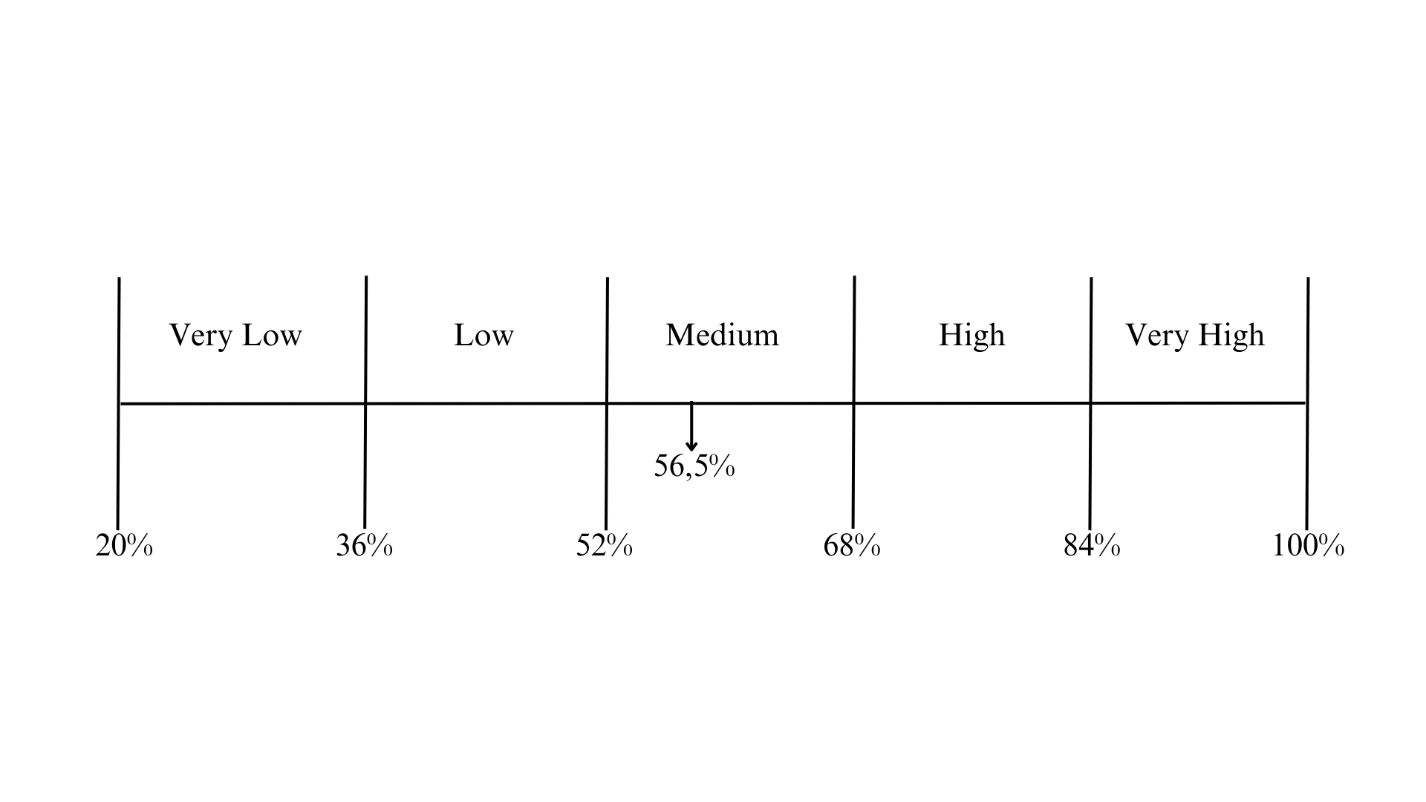
Picture 5. Continuum Line of Variable X
(Source: Researcher Processed Data, 2023)

The study examined two variables, (X) Knowledge on the negative impact of formula milk production on the environment, and (Y) Perceived Behavioral Control. The variable X was divided into two dimensions: Negative Impact on Land and Negative Impact on Air. The results showed that the overall knowledge of the negative impact of formula milk production on the environment was in the medium category (56.5%). The Negative Impact on Land dimension scored the lowest (56%) in the medium category, while the Negative Impact on Air dimension scored slightly higher (57%) in the medium category. The variable Y was divided into two dimensions: Control Belief and Power Belief. The results showed that the overall Perceived Behavioral Control was in the high category (85.5%). The Control Belief dimension scored in the high category (85%), while the Power Belief dimension scored slightly higher (86%) in the high category. In conclusion, the members of the Indonesian Breastfeeding Mother Community on Facebook have a medium level of knowledge regarding the negative impact of formula milk production on the environment. However, they have a high level of Perceived Behavioral Control, reflecting their awareness and willingness to manage individual behavior related to the perception of how easy or difficult it is to carry out a certain action. This could be a key point for members of the Indonesian Breastfeeding Mother Community in influencing or managing situations that reflect behavior.

Table 3. Respondents’ Responses to Variable (Y)
Dimensions | Indicators | Statement |  | Response |  |  |  |  | Total Score | % | Category
Dimensions | Indicators |  |  | CD | SD | N | SA | CA | Total Score | % | Category
Control Belief | Steps on Minimizing the Consumption | 1 | I feel that I have the ability to take steps to reduce the negative impact of baby formula on the environment. | 1 | 13 | 36 | 131 | 219 | 1762 | 88 | Very High
Control Belief | Steps on Minimizing the Consumption | 2 | I believe that I can make a difference in my child's milk consumption to support the environment. | 0 | 14 | 40 | 228 | 118 | 1660 | 83 | High
Control Belief | Steps on Minimizing the Consumption | 3 | I believe that I have control over my child's milk consumption decisions and can make sustainable choices. | 1 | 13 | 53 | 210 | 123 | 1650 | 83 | High
Control Belief | Steps on Minimizing the Consumption | 4 | I am confident that the small steps I take to reduce my child's milk consumption can have a positive impact on the environment. | 1 | 13 | 30 | 187 | 169 | 1716 | 86 | Very High
Control Belief |  |  |  |  |  |  |  |  |  | 85 | Very High
Power Belief | Affecting Other People/ Mothers' Perception | 1 | I am confident that my actions in raising awareness of the negative impacts of milk on the environment can influence others to participate. | 0 | 13 | 34 | 138 | 215 | 1765 | 88 | Very High
Power Belief | Affecting Other People/ Mothers' Perception | 2 | I feel that I can make a concerted effort to replace formula milk with alternative options as much as possible | 2 | 5 | 35 | 249 | 109 | 1667 | 83 | High
Power Belief |  |  |  |  |  |  |  |  |  | 86 | Very High
Average Score |  |  |  |  |  |  |  |  |  | 85,5 | High
The following is the continuum line for the Perceived Behavioral Control (Y) variable:

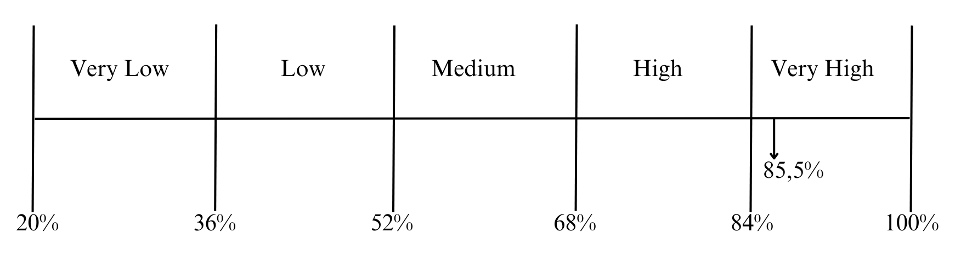
Picture 6. Continuum Line of Variable Y
(Source: Researcher Processed Data, 2023)
The research conducted a normality test to assess whether the residual values follow a normal distribution. The results, processed using IBM SPSS Statistics 25 software with the Kolmogorov-Smirnov test, showed that the significance value of the normality test results is 0.000, which is less than 0.05. This indicates that the residual value is not normally distributed. A correlation analysis was also conducted to determine the relationship between Knowledge on the negative impact of formula milk production on the environment (X) and Perceived Behavioral Control (Y). The Pearson correlation test revealed a correlation coefficient of -0.231 between these variables, indicating a low, negative relationship. This means that as Mothers’ Knowledge (X) increases, Perceived Behavioral Control (Y) decreases, and vice versa. The p-value obtained is 0.000, which is less than the alpha level (5%), signifying that the correlation between the variables is statistically significant. In summary, the research concludes that there is a low, negative, and statistically significant relationship between Mothers’ Knowledge on the negative impact of formula milk production on the environment and their Perceived Behavioral Control.
Table 4. Normality Test Results
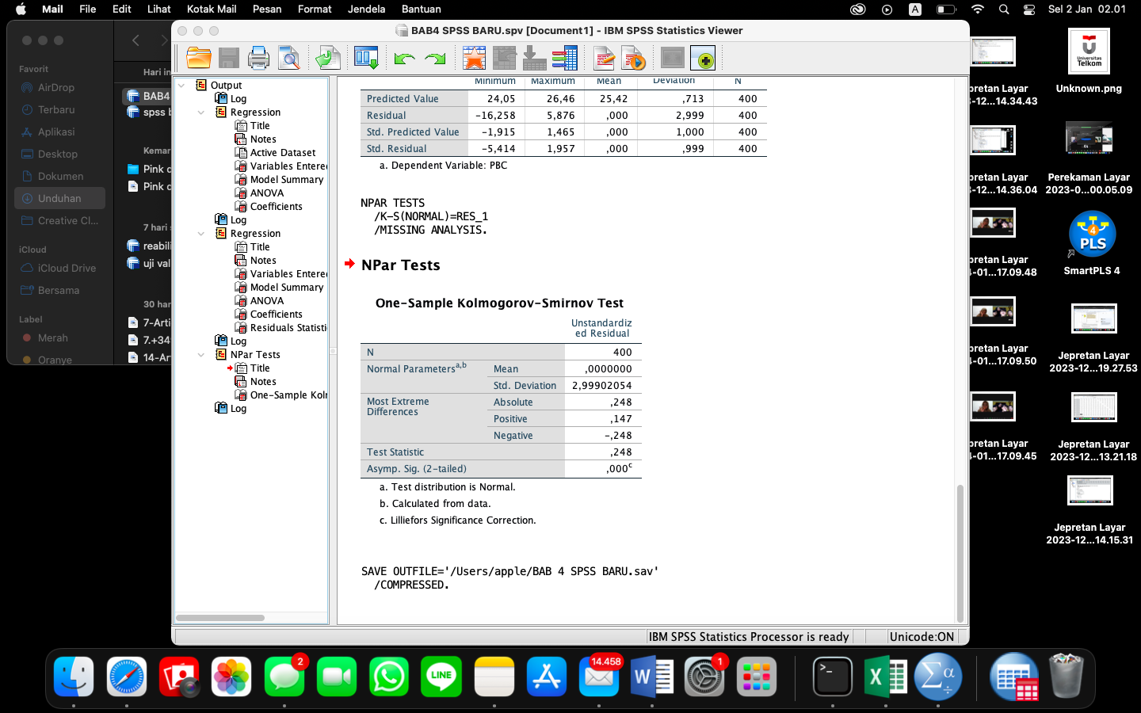
Source: IBM SPSS 25 Processed by Researchers, 2023
Table 5. Correlation Test Results
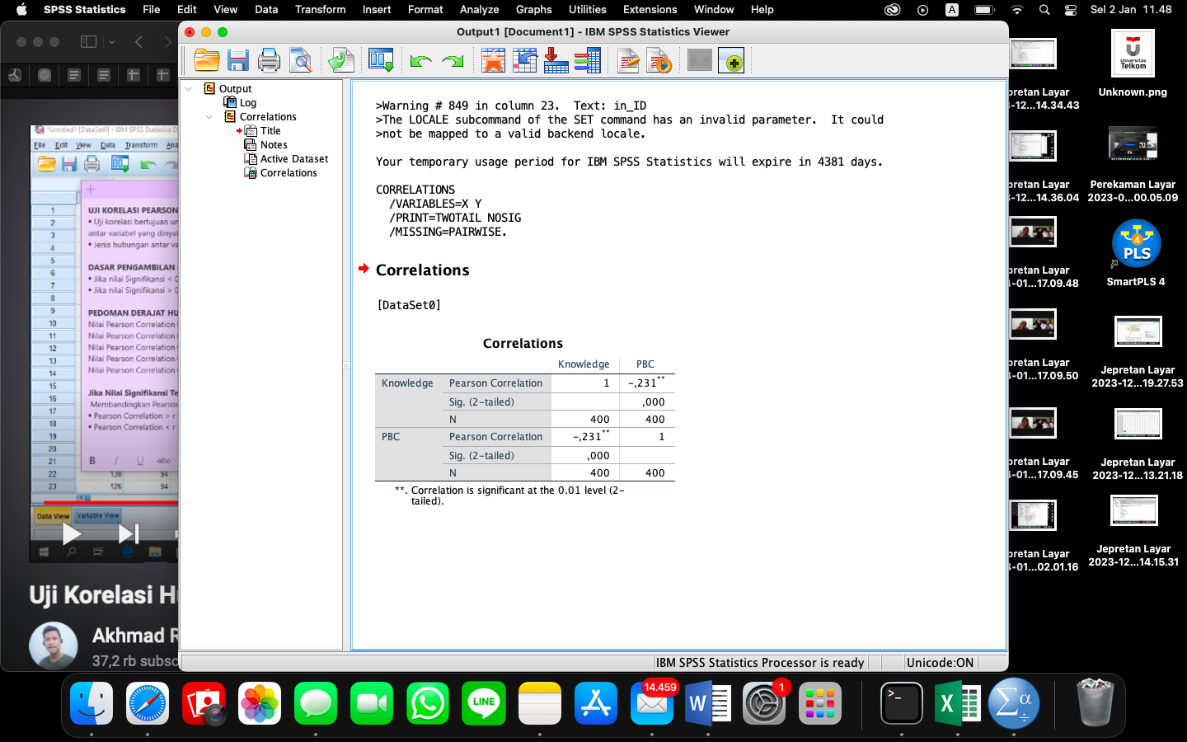
Source: IBM SPSS 25 Processed by Researchers, 2023
The research conducted a series of tests to understand the relationship between two variables: Knowledge on the negative impact of formula milk production on the environment (X) and Perceived Behavioral Control (Y). A simple linear regression test yielded the equation Y = 27.153 - 0.069X, indicating a negative correlation between X and Y. Hypothesis testing further confirmed this, showing no significant influence of X on Y. The Coefficient of Determination Test revealed that X contributes 28.2% to Y, with the remaining influenced by other variables. However, a Non-Linear Test indicated a complex relationship between X and Y that could not be explained linearly. This led to the introduction of the Cognitive Dissonance Theory, which describes the discomfort individuals experience when their actions or beliefs contradict each other. In this context, despite having lower knowledge about the negative environmental impacts of formula milk production, individuals felt capable of change. This dissonant relationship underscores the complexity of the relationship between the variables. In conclusion, the research found a significant cognitive dissonance among the members of the Indonesian Breastfeeding Mother Community, highlighting the need for further exploration and understanding of this phenomenon.

Table 6. Simple Linear Regression Test Results
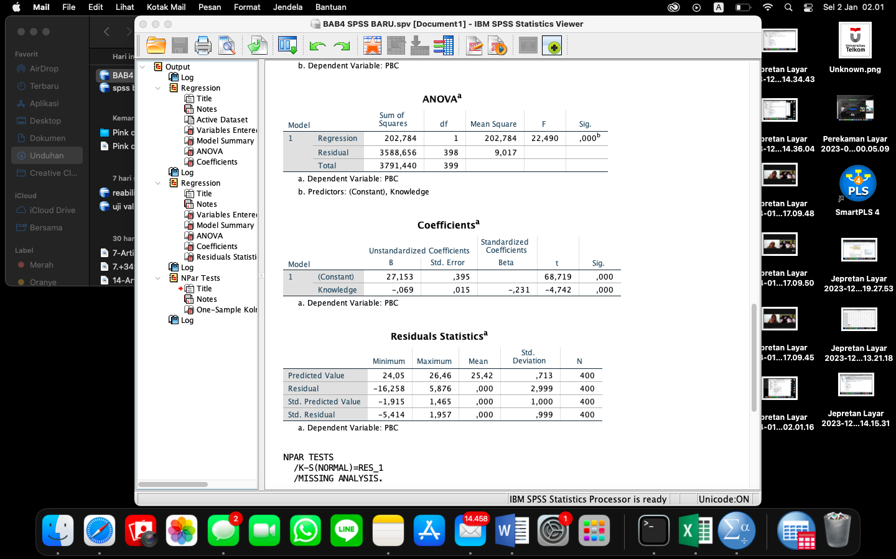
Source: IBM SPSS 25 Processed by Researchers, 2023

Table 7. Coefficient of Determination Test Results
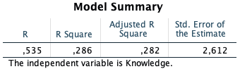
Source: IBM SPSS 25 Processed by Researchers, 2023

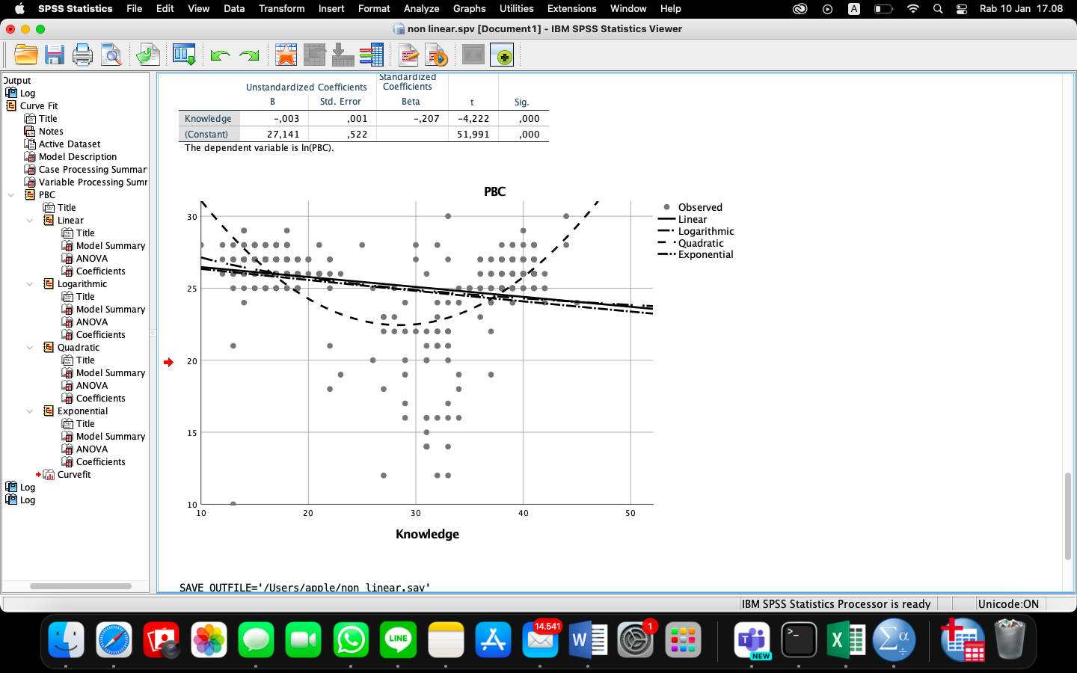
Picture 7. Non-Linear Test
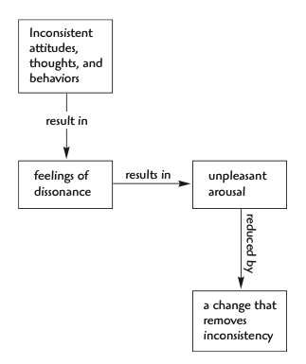
Picture 8. Cognitive Dissonance Theory
Source: West and Turner Fourth Edition Book
The research examined the variable of Knowledge on the negative impact of formula milk production on the environment, which was divided into two dimensions: Negative Impact on Land and Negative Impact on Air. The overall knowledge was found to be in the medium category (56.5%). In the Negative Impact on Land dimension, the total percentage was 56%, with the highest score being 58% (fourth statement) and the lowest score being 54% (first statement), both in the medium category. The Negative Impact on Air dimension had a total percentage of 57%. Both the first and second statements scored the highest at 59%, while the third and fourth statements scored the lowest at 55%, all in the medium category. From these results, it can be concluded that members of the Indonesian Breastfeeding Mother Community on Facebook have a medium level of knowledge regarding the negative impact of formula milk production on the environment, with the Negative Impact on Land dimension scoring slightly lower than the Negative Impact on Air dimension.
The research examined the influence of Perceived Behavioral Control, which was found to be high (85.5%). This variable was divided into two dimensions: Control Belief and Power Belief. The Control Belief dimension had a total percentage of 85%, with the highest score being 88% (first statement) and the lowest score being 83% (second and third statements). The Power Belief dimension had a total percentage of 86%, with the highest score being 88% (first statement) and the lowest score being 83% (second statement).
These results indicate that the Control Belief dimension had the lowest score on the Perceived Behavioral Control variable, while the Power Belief dimension scored slightly higher. It can be concluded that members of the Indonesian Breastfeeding Mother Community on Facebook have a high level of Perceived Behavioral Control, reflecting their awareness and willingness to manage individual behavior related to the perception of how easy or difficult it is to carry out a certain action. This could be a key point for members of the community in influencing or managing situations that reflect behavior.
The research examined the influence of Mothers’ Knowledge on the Negative Impact of Formula Milk Production on the Environment (X) on their Perceived Behavioral Control (Y). Descriptive analysis showed that the average percentage of knowledge was in the medium category (56.5%), with the highest percentage in the Negative Impact on Air dimension (59%) and the next highest in the Negative Impact on Land dimension (58%). Perceived Behavioral Control (Y) was found to be in the high category (85.5%), with both the Power Belief and Control Belief dimensions scoring the highest percentage (88%). A correlation test and a simple linear regression test were conducted to determine the relationship and influence between X and Y. The regression equation derived was Y = 27.153 - 0.069X, indicating a negative relationship between X and Y.
Hypothesis testing showed that the significance value of the regression coefficient is less than 0.05, concluding that Knowledge on the negative impact of formula milk production on the environment has a significant effect on Perceived Behavioral Control. However, the T-test results led to the rejection of the alternative hypothesis (H1) and acceptance of the null hypothesis (H0), meaning there is no influence of mothers’ knowledge (X) on their perceived behavioral control (Y) regarding the negative impact of formula milk production on the environment. The coefficient of determination test showed that X contributes 28.2% to Y, with the remaining influenced by other variables. In summary, the research concludes that while mothers’ knowledge increases, their perceived behavioral control decreases, indicating a negative correlation between the two variables.
The research reveals that members of the Indonesian Breastfeeding Mother Community on Facebook have a moderate level of knowledge about the negative environmental impacts of formula milk production. However, they exhibit a high level of Perceived Behavioral Control, indicating a strong belief in their ability to enact behavioral changes. The study identifies a disparity between these two variables, suggesting cognitive dissonance between awareness levels and perceived control over behaviors. Despite their knowledge about the environmental consequences of formula milk production, this does not significantly influence their perceptions of behavioral control. This highlights the need for interventions to address this cognitive dissonance and promote alignment between awareness and behavioral intentions within this community.

CONCLUSION
In summary, this study examined the understanding of the Indonesian Breastfeeding Mother Community on Facebook about the negative impacts of formula milk production and their perceived ability to influence behaviors. Despite a moderate understanding of the environmental impacts, there was a high belief in their ability to enact changes, indicating a disconnect between awareness and action. The findings suggest the need for interventions to address this cognitive dissonance and empower community members with strategies for environmentally sustainable behaviors. Further research is recommended to explore the variables not included in this study and the barriers to translating knowledge into action. Practical suggestions include strengthening the community’s knowledge about the negative impacts of formula milk production and using the community as a platform for sharing this information. Government interventions to disseminate information about the adverse effects of formula milk production are also suggested. These steps aim to promote more sustainable practices within the breastfeeding community and contribute to positive environmental outcomes.

REFERENCES

Abdullah. (2015). Metodologi Penelitian Kuantitatif. Aswaja Pressindo.
Ajzen, I., & Fishbein, M. (1977). Attitude-behavior relations: A theoretical analysis and review of empirical research. Psychological Bulletin, 84(5), 888.
Alsahafi, A. J., & Cheng, A. C. (2016). Knowledge, attitudes and behaviours of healthcare workers in the Kingdom of Saudi Arabia to MERS coronavirus and other emerging infectious diseases. International Journal of Environmental Research and Public Health, 13(12), 1214.
Budiman, & Riyanto, A. (2013). Kapita selekta kuesioner pengetahuan dan sikap dalam penelitian kesehatan. Jakarta: Salemba Medika, 66–69.
Crano, William D., Marilynn B. Brewer, and A. L. (2023). Principles and methods of social research. ROUTLEDGE.
Hardani, N. H. A., Andriani, H., Fardani, R. A., Ustiawaty, J., Utami, E. F., Sukmana, D. J., & Istiqomah, R. R. (2020). Metode Penelitian Kualitatif & Kuantitatif. CV. Pustaka Ilmu.
Hendriawan, L. T., & Ghina, A. (2016). Identifikasi Attitude Toward Behavior, Subjective Norm, Dan Perceived Behavioral Control Sebagai Faktor Pendorong Berwirausaha (studi Pada Wirausaha Dengan Tingkat Pendidikan Akhir Sekolah Menengah Atas). EProceedings of Management, 3(2).
Jaya, I. M. L. M. (2020). Metode Penelitian Kuantitatif dan Kualitatif. Anak Hebat Indonesia.
Kompas Team. (2022, December 30). Formula Milk Spending Amounts to Rp 3 Trillion per Year. Www.Kompas.Id. https://www.kompas.id/baca/english/2022/09/30/formula-milk-spending-amounts-to-rp-3-trillion-per-year
Mahcene, Z., Abdellah, M., Zergoune, M., & Lacheheb, M. (2019). Land degradation and economic development in Algeria. International Journal of Energy Economics and Policy, 9(1), 137–142. https://doi.org/10.32479/ijeep.6947
Mardikaningsih, R. (2019). Pengaruh Persepsi Kualitas dan Persepsi Resiko terhadap Keputusan Pembelian Susu Formula. Ekonomi, Keuangan, Investasi Dan Syariah (EKUITAS), 1(1), 1–8.
Mawardani, M. A. K., Mutyara, K., & Wiramihardja, S. (2023). Knowledge, Subjective Norm, Attitude, Perceived Behavior Control, Intentions About Hemoglobin in Pandemic Pregnant Women. Jurnal Health Sains. https://api.semanticscholar.org/CorpusID:258149183
Merry, Y. A., Ponda, A., Hayati, N. F., & Doni, A. W. (2023). Peningkatan Pengetahuan Ibu Terhadap Gizi Dan Keterampilan Olah Daun Beluntas Untuk Meningkatkan Produksi ASI Kota Padang. Jurnal Pengabdian Masyarakat Cendikia Jenius, 1(1), 36–42.
Miot, H. A. (2018). Correlation Analysis in Clinical and Experimental Studies. Jornal Vascular Brasileiro, 17(4), 275–279. https://doi.org/https://doi.org/10.1590/1677-5449.174118
Notoatmodjo. (2010). Metodologi Penelitian Kesehatan. Gramedia Pustaka Utama.
Nuary, F. D. (2010). Implementasi Theory of Planned Behavior Dalam Adopsi E-Commerce Oleh UKM. Jurnal Universitas Sebelas Maret Surakarta., 21–25.
Pratama, V. O. P., & JAR, N. R. (2020). Analisis Beban Emisi Gas Karbonmonoksida (CO) dan Karbondioksida (CO2) dari Aktivitas Transportasi Umum di Terminal Arjosari Kota Malang. Prosiding ESEC, 1(1), 69–78.
Purusottama, A. (2019). Revisiting Students’ Entrepreneurial Intention in Indonesia: a Theory of Planned Behavior Approach. Jurnal Manajemen Dan Kewirausahaan, 21(1), 64–73. https://doi.org/10.9744/jmk.21.1.64-74
Purwanto, E., Syam, M., & Hendryadi. (2023). Penerapan theory of reasoned action: studi kasus pada wisata sejarah. INOVASI: Jurnal Ekonomi, Keuangan Dan Manajemen, 19(3), 750–759.
Santoso. (2018). Menguasai Statistik dengan SPSS 25. Elex Media Komputindo.
Setiawan, M., & Setyawati, C. Y. (2020). The Influence of Perceived Ease of Use on the Intention to Use Mobile Payment. https://api.semanticscholar.org/CorpusID:219927176
Smith, J. P. (2019). A commentary on the carbon footprint of milk formula: harms to planetary health and policy implications. International Breastfeeding Journal, 14(1), 1–7. https://doi.org/10.1186/s13006-019-0243-8
Sugiyono, & Lestari, P. (2021). Metode Penelitian Komunikasi (Kuantitatif, Kualitatif, dan Cara Mudah Menulis Artikel pada Jurnal Internasional). CV. Alfabeta.
Taherdoost, H. (2021). Data collection methods and tools for research; a step-by-step guide to choose data collection technique for academic and business research projects. International Journal of Academic Research in Management (IJARM), 10(1), 10–38.
Turner, M. (2023, S. 19). L. M. H. testing. R. from latrobe. libguides. co. website: https://latrobe. libguides. com/maths/hypothesis-testing#:~:text=Hypothesis%20testing%20is%20a%20systemati. (n.d.). No Title.
Utina, R. (2008). Pendidikan lingkungan hidup dan konservasi sumber daya alam pesisir. Universitas Negeri Gorontalo, Gorontalo.
Wagini, R., Karyono, & Budi, A. S. (2002). Pengolahan Limbah Cair Industri Susu (Liquid Waste Management in Milk Factory). In Jurnal Manusia dan Lingkungan (Vol. 9, Issue 1, pp. 23–31).
Wahana, P. (2016). Filsafat Ilmu Pengetahuan. In Pustaka Diamond. Pustaka Diamond.

