Using Metaphors to Reduce the Uncertainty in Play Therapy Room
Universitas Pancasila
Jl. Lenteng Agung Raya No.56, RT.1/RW.3, Srengseng Sawah, Kec. Jagakarsa, Kota Jakarta Selatan, Daerah Khusus Ibukota Jakarta 12630
tribuanatunggadewi@univpancasila.ac.id

ABSTRACT
This paper is based on the results of observations by a therapist in the play therapy room when conducting session with children clients. As one of the methods in psychotherapy, a play and creative art therapist must be able to establish good relationships with clients so that clients feel safe and comfortable during the therapy process. This safe and comfortable relationship can later help clients feel the same way in situations outside the therapy room. Thus when interacting with other human beings, clients will become individuals who are emotionally, psychologically and socially healthy. In order to establish a safe and comfortable relationship, a process of reducing uncertainty between therapist and client is needed when communicating in the therapy room. Berger and Calabrese (in West and Turner, 2010) consider reducing uncertainty will result in self-disclosure which can strengthen the source-receiver relationship in communication process. In the context of the play therapy room, the reduction of uncertainty and the emergence of self-disclosure takes place uniquely by using various metaphors that client chooses independently. The metaphors chosen by clients besides breaking the rigidity the therapist-client relationship at the entry phase, also help develop better relationship on the personal and exit phase.

Keywords: Health communication, interpersonal communication, uncertainty reduction, self-disclosure, play therapy.

ABSTRAK
Artikel ini berdasarkan hasil observasi terapis di ruang play therapy saat melakukan sesi dengan klien berusia anak-anak. Sebagai salah satu metode dalam psikoterapi, seorang play and creative arts therapist harus mampu menjalin hubungan baik dengan klien agar klien merasa aman dan nyaman selama proses terapi. Hubungan yang aman dan nyaman ini nantinya dapat membantu klien merasakan hal yang sama dalam situasi di luar ruang terapi. Dengan demikian ketika berinteraksi dengan manusia lain, klien akan menjadi individu yang sehat secara emosional, psikologis, dan sosial. Untuk menjalin hubungan yang aman dan nyaman, diperlukan proses pengurangan ketidakpastian antara terapis dan klien saat berkomunikasi di ruang terapi. Berger dan Calabrese (dalam West dan Turner, 2010) menganggap pengurangan ketidakpastian akan menghasilkan keterbukaan diri yang dapat memperkuat hubungan sumber-penerima dalam proses komunikasi. Dalam konteks ruang terapi bermain, pengurangan ketidakpastian dan munculnya keterbukaan diri terjadi secara unik dengan menggunakan berbagai metafora yang dipilih klien secara mandiri. Metafora yang dipilih klien selain mencairkan kekakuan hubungan terapis-klien pada fase entry, juga membantu mengembangkan hubungan yang lebih baik pada fase personal dan fase exit.

Kata Kunci: Komunikasi kesehatan, komunikasi interpersonal, pengurangan ketidakpastian, keterbukaan diri, terapi bermain.

INTRODUCTION
Uncertainty reduction is one of the keys to successful development of sender-receiver relationships when conducting interpersonal communication. Reducing uncertainty is believed to make an interpersonal relationship more certain because both parties who communicate can get to know each other. Usually the process of reducing uncertainty will begin by asking each other questions regarding general matters and then progress to more personal questions. Each individual has subjectivity in determining which questions are general and which are personal. It is possible when communicating with someone a question like, “Where do you live?” Felt by receiver as a personal question. Meanwhile for others, the question is considered a general question.
The process of reducing uncertainty is needed in all forms of interpersonal communication. This includes client and therapist communication in play and creative arts therapy. Play and creative arts therapy is a method of psychotherapy to intervene individuals with psychological, emotional, & social issues. Initially this method was used for child clients. In its development, play and creative arts therapy can also be used as an intervention for adults. During the session, the client chooses the tools they want to use while the therapist follows the client's process and joins to play. During the session, clients generally send more nonverbal messages and use various metaphors through the tools they choose. The therapist's jobdesk is to accompany and capture the messages sent by the child during the session so that he/she feels safe, heard, understood, and accepted for who he/she is (CAE, 2021).
One of the keys to success in therapy is the trust of the client. Trust will pave the way for clients to be able to undergo the therapy process with a sense of security and comfort. Building trust requires a process of reducing uncertainty so that the client-therapist relationship can run smoothly. In play and creative arts therapy, the process of reducing client-therapist uncertainty cannot be done by questioning. This is because the method used is more often non-directive where the client is free to choose what he/she want to do during the session. In the room, the therapist will give client the opportunity to choose and explore the tools provided. This was emphasized by Axline (1981) in one of the principles of play therapy, in which the client is free to express his feelings and respects the client's ability to solve his problems independently. In the therapy room, clients express their behaviour and emotions using various tools, including: Arts, sand, clay, puppet and mask, therapeutic story, creative visualization, music, movement and dance. While the therapist will accompany the client while reflecting and equating his energy with the client's energy. Thus, the client and therapist relationship can become in tune and make the client find a better version of him/herself.
As a play and creative arts therapist, one of the case that I handle is the case of ANA. ANA are referred to attend sessions by their parents with the aim of being more mentally prepared, having better focus, and being able to share and be more patient. When attending therapy the client was 5 years 8 months old and was in 1st grade. There are not many concerning comments from the client's homeroom teacher, apart from the client not being focused in class. According to the homeroom teacher, the client did a lot of inappropriate activities while studying. For example, hiding under the table, inviting friends to chat during class hours, cannot cooperate with friends and occasionally crying when not happy with certain situation. This is still considered reasonable by the homeroom teacher, considering the age of ANA who are still below her classmates. In contrast to the teacher's comments, the client's parents seemed very worried. During the pre-session interview, the client's mother repeatedly exhaled, as if indicating fatigue or frustration when explaining the client's case. According to Mother, ANA are easily anxious and afraid of many things. A few weeks before the initial interview was conducted, ANA wet the bed twice at night. Both parents explained that the same thing happened when the their family were still living in Bandung (this family moved to Jakarta when ANA was about to enter elementary school). ANA’s father considers her as a sensitive child, in contrast to his two older siblings (a boy, aged between 17-18 years at the time of the pre-session interview and attending school outside the city and abroad). Both parents admitted that they did not plan to have more children when they found out that ANA’s mother was pregnant with ANA. However, both of them explained that they were very excited when they found out that the fetus they were carrying was female. ANA’s main caregiver is her Mother. She is a homemaker, but regularly visits the ANA’s grandfather who lives in West Java. When the mother takes care of the grandfather, ANA’s father will fully in charge of her.
As therapist, I feel the relationship in the ANA’s family is quite unique and dynamic. Every day they will do the evening prayer through facetime so that the ANA’s two older siblings can pray together with them. The family also regularly visit each other during holidays or at their spare time. The division of who taking care of ANA is also quite clear and balance, where the role of the father and mother are complement each other. However, ANA’s mother admitted that she was tired of taking care of ANA. I suspects that maybe this is due to the large age gap between the client and her two older siblings and an unplanned pregnancy, so that the client's parents, especially the mother, are not ready for the presence of ANA.
Santrock (2011) describes the process of human growth and development occurs in three processes: Biological, cognitive, & social-emotional. Within the scope of biological processes, physically ANA’s development is suitable with her age. But the development of the client's motor skills still need more attention. Especially her gross motorskill is not develop consistency with her age, Cognitively, ANA language development is good. In fact, according to parents and teacher, ANA is excel in language. She even consider as having several intention to conduct manipulative behaviour. For example she knows when to cry to get extra attention. Academically based on report cards, ANA is also doin alright. Based on the three processes of development, the most notes on clients are social-emotional processes. Based on the explanations of parents, teachers, and sensory integration therapists who also treat clients, ANA is prone to mood swings when compared to other children of her age. According to his parents, he also often admits to having stomachaches, dizziness, and bedwetting when worried. This anxiety occurs when ANA experiences pressure such as being uncomfortable with a certain situation, making new friends, or not being able to reach the target she expected.
Compared to other clients, ANA is one of the cases that consider as challenging. Until now, ANA is the client with the highest number of sessions that I have ever handled. One of the obstacles in the therapy process that occurs is in the process of reducing uncertainty. In the case of other clients, although it is rare for client-therapist to ask directly, the process of reducing uncertainty occurs relatively smoothly. Most clients will go through the process of reducing uncertainty by matching their interests with those of the researcher or seeking approval. Either by asking if it's okay to try doing certain activities, or by directly inviting to play together. In ANA's case interactions in the early sessions were mostly done in a commanding manner. She directs a lot. ANA also always choose to act as the dominant party when playing and do not give me the opportunity to change roles. Based on this, the researcher took the ANA Client case study as a research focus to find out how the process of reducing uncertainty occurs in the play and creative arts therapy space.
LITERATURE REVIEW
Berger and Calabrese believe increasing predictability when strangers meet for the first time, will be their primary concern. By increasing predictability sender-receiver communication process will became smoother and making sense of what is communicate will be easier for both parties (West and Turner, 2010). As a process to understand more our receiver in interpersonal communication, uncertainty reduction has both proactive and retroactive processes. Proactive uncertainty reduction happens when a person thinks about communication options before engaging with another person. While retroactive uncertainty reduction consists of attempts explaining behavior after the encounter itself.
A lack of information will develop uncertainty in interpersonal communication process. Uncertainty itself will undermines your ability to communicate. The more uncertainty exist, the more difficult to set goals for the conversation, to plan a course of action, and to enact verbal and nonverbal messages. Berger and Calabrese (1975) in Solomon and Theiss (2013) explained our initial interactions with other people usually focused on gathering information that will help us communicate. This is the process they called uncertainty reduction. In order to rise the certainty in the formative stages of relationship development, we exchange information. At first, it can occur through self-disclosure.
Self disclosure is the activity of telling another person about our characteristics, experiences, feelings, attitudes or beliefs. Within initial interactions, your self-disclosures focus on public information, such as name, age, and hometown (Greene, Derlega, & Mathews, in Solomon and Theiss, 2013). Self disclosure will helps us navigating initial interactions. To cope with uncertainty about how to communicate in initial interactions, people follow a norm of reciprocity, the tendency to match our own disclosures to those made by our partner (for example, use of explicit language, humor, or politeness).
In play and creative arts therapy session, client will also reduce uncertainty when meeting the therapist. Uniquely, because this psychotherapy method conducted in non-directive way, then question and answer process which is usually done to increase certainty rarely occurs. To understand why this therapy method considers the importance of non-directive processes, can be explained by understanding the Axline Principles (1981). Virginia Axline explained eight basic principles in play therapy. The eight principles are: (1) The therapist must create a warm, friendly relationship to create a good relationship with the child as soon as possible. (2) The therapist accepts the child as it is. (3) The therapist creates freedom in children, so that children feel free to express their feelings. (4) The therapist has to be able to recognize the feelings expressed by the child and reflect back on those feelings so the child have the ability to gain insight from his/her behavior. (5) Therapist respects the child's capacity to solve his/her own problems and also their responsibility for making choices and changes that the child consider as important. (6) The therapist does not direct the child's actions or conversations in any form. (7) The therapist has to believe that therapy is a process that do not need to be done in a rush. (8) The therapist has to establish boundaries.
Every therapy session will start by therapist greeting and informing client about the session rules: Session lasts for 45 minutes. Anything in the room stays in the room. Cllient, therapist, and all the things around the room always have to be in safe condition. Then the rest of the session will follow leads by the client, while therapist accompany client by reflecting on what client say or do that consider might lead client to his/her better psychological, mental, and or social condition. Most of the time client will communicate nonverbally and use many metaphor. These metaphor can be communicate through client’s nonverbal message, activities they choose, and also the typical tools they desired to use.
Mills and Crowley (2014) summarize some definition of metaphor from many experts. Kopp, consider metaphor as a means of communicating in which one thing is expressed in terms of another. Methapor as a new expression, however, cannot be fully understood by the conscious mind. Erickson and Rossi (1979) in Mills and Crowley (2014) theorizing about the important link between metaphor, symptoms, and therapeutic intervention. Since the right hemisphere is also more involved than the left in mediating emotional and imagistic processes, it is believed likely that psychosomatic symptoms are processed by predominantly right-brain functions. This mean, the right brain may be the “home” of both metaphorical language and psychosomatic symptomatology. Erickson and Rossi theorized that since “symptoms are expressions in the language of the right hemisphere, our use of mythopoetic language may thus be a means of communicating directly with the right hemisphere in its own language” They believe that this right-hemispheric mediation of both symptomatology and metaphorical meaning would explain why metaphorical approaches to therapy were less time-consuming than psychoanalytically oriented approaches.
The power of metaphor in therapeutic process can be find in many literature. Stuart and Ryan (2020) mentioned that Metaphors may provide people in pain with therapeutic value when used carefully by professional. Similar conclusion also stated by Haen (2020) that explain by exploring metaphor and imagination as transtheoretical elements that cut across therapy modalities, clinicians might ultimately sharpen their effectiveness in helping children heal from the traumatic events in their lives. While Zatloukal, Žákovský, and Bezdíčková (2019), acknowledge though the therapeutic work with metaphors represents a real creative challenge, but it creates something new and potentially transformative for clients. In the case of pregnancy loss, Littlemore and Turner (2019) found that metaphor is a useful tool in providing insights into people’s experiences of pregnancy loss. And Nardon and Hari (2021) conclude that imaginative metaphors allow participants to explore feelings, assumptions, and behaviors in non-threatening ways and facilitate introspection and self-awareness.
Mills and Crowley (2014) highlighted that the most important information therapists can elicit from the child is that of positive experiences (hobbies, movies, cartoon characters, playmates, animals, events, memories, and so others), which have had a beneficial effect. They focus on eliciting positive experiences. This is contrary with traditional approaches in which emphasis on the problem area. In traditional approach most therapist are trained to be aware of the power wielded by painful memories and traumas. Most attention has been accorded the negative side of the scale. Mills and Crowley suggested to give balance on understanding the metaphor that used by client, so that the client’s journey of go into his/her unique inner world can be easier. In addition, Brink (1982) in Mills and Crowley (2014) believed that focusing on client’s positive experience will help them to form the “background structure” of the metaphor, using scenes, activities, and occurrences already familiar to the child.

METHOD
This research is a descriptive case study with observational data collection techniques. In this research researcher acts as a therapist involved in handling client ANA case. ANA is a 5 years and 8 months old girl that consider having difficulties in some psychological and social aspect of her development. Client ANA was chosen because she had the longest session. Based on this, the research can have longer observation time so that can produce in-depth data. In addition, the ANA also considered as one of the challenging clients in the process of reducing uncertainty.
RESULTS AND DISCUSSION

During therapy session, more often the sessions conducted in non directive way. Until session 14, ANA tend to give many directions on me. It feels like she tried to dominate the session. Based on information from a sensory integration therapist who handled ANA for 3 months before play therapy session, clients often act bossy and get annoyed or cranky if the therapist not following what she wants. However, in the play room ANA never showed any signs of being angry or cranky. She very playful, even though she often directs the therapist a lot. The intensity of directing while playing also decreases as the session increases. From the 14th session onwards, clients can be said to be able to work together well and at the same time be able to play independently. If sensory integration therapists and teachers at school say clients like to command, the therapist actually feels that clients basically just needed to be accompany but ANA do not understand how to make friends. This is in line with the teacher's statement that ANA has small amount of good friends. Parents also acknowledge this situation with peers.
Since entering the 14th session the variety of tools ANA used was increasingly diverse and I can felt the maturity and mindfulness that increasingly emerged. For example, in the 14th session, when making a pencil case from ice cream sticks, it can be said that almost 45 minutes of the 14th session were used by the client to finish the work. ANA also looked very persistent and focused. In this session, ANA said that she wanted to make her parents proud. In the 15th session, the client did a "new" activity, namely painting masks. However, according to her, the first mask she painted was wrong and was immediately thrown away. ANA then took the second mask and painted on the mask. Until the 24th session, clients still have a tendency to did everything in a perfect condition and not be easily satisfied. Even though later on, if she is not satisfied, ANA does not give up or throw away the work, instead she will continue to try to finish his work as well as she expects.
ANA’s play theme almost always about family, party, and dining. The figurines used are almost always the Disney princess, prince, Cinderella's stepmother & stepsisters. Often ANA will do roleplay as if we are in the supermarket or in the beauty parlour. The same game theme keeps repeating until the 12th session. After the 12th session, ANA began to share more stories about herself. For example, in the 13th session, ANA began to notice that she often stuttered when speaking and she realized that stuttering would occur when she was in a hurry. She can gain insight that when she is not in a hurry she will not stuttered. She also realize that at that moment she less frequent stuttered at school. When I reflected what she said, ANA said she realized this because a friend at school said that ANA stutters less and less lately.
Starting from the 14th session, ANA chose more producting or building activities. In the 14th session ANA made pencil case from ice cream sticks, on the 15th session she painted masks, on the 17th & 18th sessions she made play dough, on the the 20th session she painted on paper & masks, on the 21st session she painted masks (which she said modelled by my make up at that day). On the session 22 to 24 she made a thank you card for me.
When playing, ANA quite often do role play. She likes to play the role of an adult who is strict and rules a lot. For example, when playing a princess figurine, ANA prefers to act as Cinderella's Mother or Stepsister rather than Cinderella. She is also happy to be Prince Charming who can chose a future wife. If it doesn't suit her taste then Prince Charming will kick the princess. Other role-playing games that clients often engage in are supermarkets, restaurants and salons. When playing she usually prefers to be an officer. As a client officer will act decisively and fiercely. As the session increases, the ANA is also became more assertive when playing the role. She gradually became more and more friendly "client service". Even toward the end of a session clients tend to serve more than giving command during role plays.
Because ANA tend to play with the same theme over and over again, I suspected that ANA is a rigid child. But after going through a mid-session review with parents, I conclude that ANA more accurately described as a child with narrow discourse. ANA is not exposed to many stimulants. What she got is just about that theme, so her intereset became very limited. This is conclude especially after a mid-session review with the parents. During the review, both parents admitted they had limited time & were tired of accompanying clients.
One of the activities that clients often do is tell stories. If in the early sessions the client often made up stories when playing figurines and role playing, after entering the mid-session ANA often told me about her feelings. Usually she mentione this while playing. This showed how important play is for children that still cannot process their feeling verbally. For example, when making playdough, she told me about her house, which always have to be tidy. Because of it, ANA is not allowed to play playdough anymore. If previously the client spoke a lot in a hurry and stuttered, the longer the client becomes more relaxed and able to speak coherently. After attending 24 sessions, ANA became more focused, explorative & patient. The variety of activities and topics of conversation she chose also more diverse. ANA also can tell when she is happy, when she is sad, and how to respond to those situations.
In the process of reducing uncertainty, various literature states that self-disclosure is required to increase certainty by conducting question and answer. This did not happen in play and creative arts therapy sessions because the method used was non-directive. Therefore reducing client and therapist uncertainty can only be done by using various available tools. Even though ANA talk a lot during their activities, the nonverbal messages she sent are much deeper and help the therapist in reducing uncertainty.
One of the things that clients do in the process of reducing uncertainty is through arts activities in the fifth session. ANA drew a house and a tree based on my suggestion. When ANA chose the drawing tool, she refuses to use crayons and prefers to draw with colored pencils, pencils and markers. The first time she drew a house. When about to start drawing ANA said that she will draw a castle. Then she took a black marker and made the castle. After she finished the drawing, then she seemed to remember that she should use a pencil first. The client seemed a bit panicked and tried to find a pencil. But this panic did not last long, when she heard me say, "anything can be anything in this room," she returned to drew with her black marker. After the main frame of the house was finished, she looked at the drawing for a while, then said that this palace needed lots of windows. Then she made windows. Lots of windows with grid. Just like a prison. The castle she made has three towers, also with grid on its windows. Each tower has a closed door. So, in total there are 3 doors in her castle. Below is the drawing created by ANA.
Picture 1
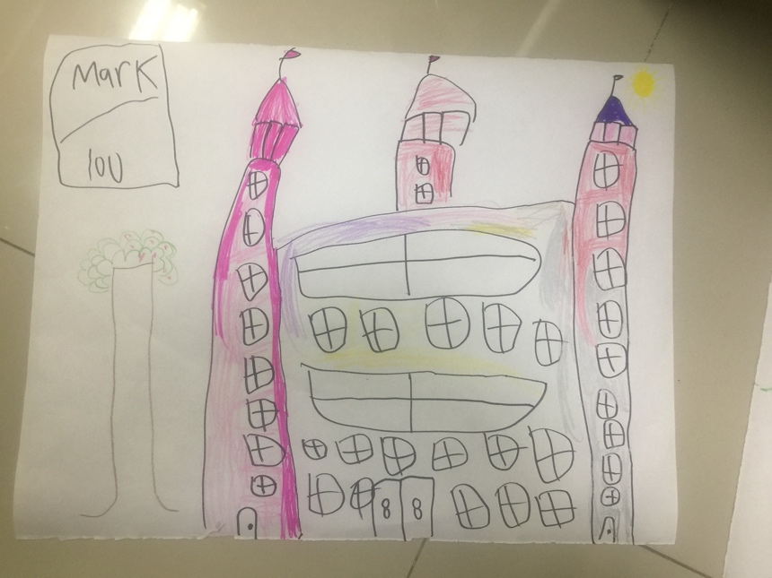
The castle seemed to be complete. It has doors, windows, towers, and even flag in each tower. Initially, ANA drew only two large windows with grid. Then she added lots of small windows with grid because she said the castle needed more windows. When I reflect by saying, "I heard ANA said the castle needs more windows." ANA answered firmly while looking at the resulting drawings and said, “Yeah…the castle need lots of windows.”
The client took a long time to drew the castle. After the castle finished, ANA seemed to suddenly remember something. "Oh..we need to put a mark on the drawing." At first I did not understand what shw meant. So I reflect by saying, "ANA said it is necessary to put a mark on the drawing." ANA nodded then she wrote the word “Mark: 100”. When seeing this writing, I realized that she felt the need to give an assessment of her drawing. Then I reflected again by saying: "I see you wrote Mark 100 on the paper." ANA replied by saying, "Mark is very important."
Because the session is almost finished so I remind ANA that she has not made the tree and the person. At first, ANA said that there were not enough space for trees and people in the paper because the castle was so big. I reflected by saying: "ANA said the castle is too big." While repeating her words, ANA took colored pencils and drew a small tree. This tree is barely visible because it's in pencil. Very contrast compared to the image of the castle that drew by markers. Though the tree was not clearly visible, ANA draws a relatively complete tree. The tree has green leaves (although they are not shady), there are small red fruits (although they do not fill the entire collection of leaves), But she did not drew the roots on her tree. Because the session has come to an end, so ANA did not have time to drew the person. She said she might going to draw the person next week.

This arts activity is a recommended activity by therapist. This activity was chosen as a way to reduce uncertainty. Through drawing activities therapist can get a general idea about ANA without asking questions. From ANA’s drawing and the reflection by therapist, I can recognize ANA as a cheerful, enthusiastic and imaginative child. This can be conclude through the energy and pace ANA used while she drew her house. ANA drew in a fast pace. She did not gave time to reflect on what she drew. She just kept picking new color and creating more object while busy explaining this and that. Her huge energy can be identified by how she can manage to draw while talking simultaneously. Her multitasking activities made her lost focus sometime. For example when the time almost finished she realize that I asked her to draw house, tree, and person. Not only house. When she realized this, she seems a bit disappointed. It is shown by her nonverbal messages. Her eyes look a bit teary, her voice getting lower, and her shoulders dropped. Another interesting finding based on this activity is that the importance of marking the drawing. As we can see on the drawing she gave a marking on her own drawing. This might tell us how she feels important to have good grades or the importance to be always in perfect condition.
Based on the picture, I sense that client felt her family is sort of divided.. This is indicated by the picture of the house which seems to be divided into three parts: the main house, the first tower, and the second tower. Even though the color of the castle looked cheerful, these seem to tell the story in the client's family there are firm boundaries. The number of windows can be a picture that the client needs the understanding of others to be able to understand himself and his family. Another thing that is also interesting was all the grided windows. It could be that this illustrates that ANA needs clear boundaries when other people try to get to know her and her family. On the other side, the grided window might also meant that ANA feels confined by the rules given to them in their environment.

Pictures of trees that are not as clear as a house with leaves that are not too lush, little fruit and no roots, might indicate that the client is still in a period of growth and development in his five psychological aspects, namely; Unconscious states from the field of general psychology, states of unconscious development, levels of psychosexuality and maturity, contact with reality, and feelings of interpersonal balance. I think this is still within reasonable limits considering that the client is not yet six years old. Or another indication is that the client has not seen and practiced drawing trees much, so this is the shape of the tree that he understands. I have a feeling the client will still very much improve in this area as time goes on. When a client draws a tree, I ask if this tree has fruit? The client answered while drawing small red fruit on the tree. This indicates that maybe ANA drew trees like this because she did not have many references about trees. Not because of any serious psychological problems.

On the sixth session, ANA chose to play with figurine. These are the figurine she chose.
Picture 2
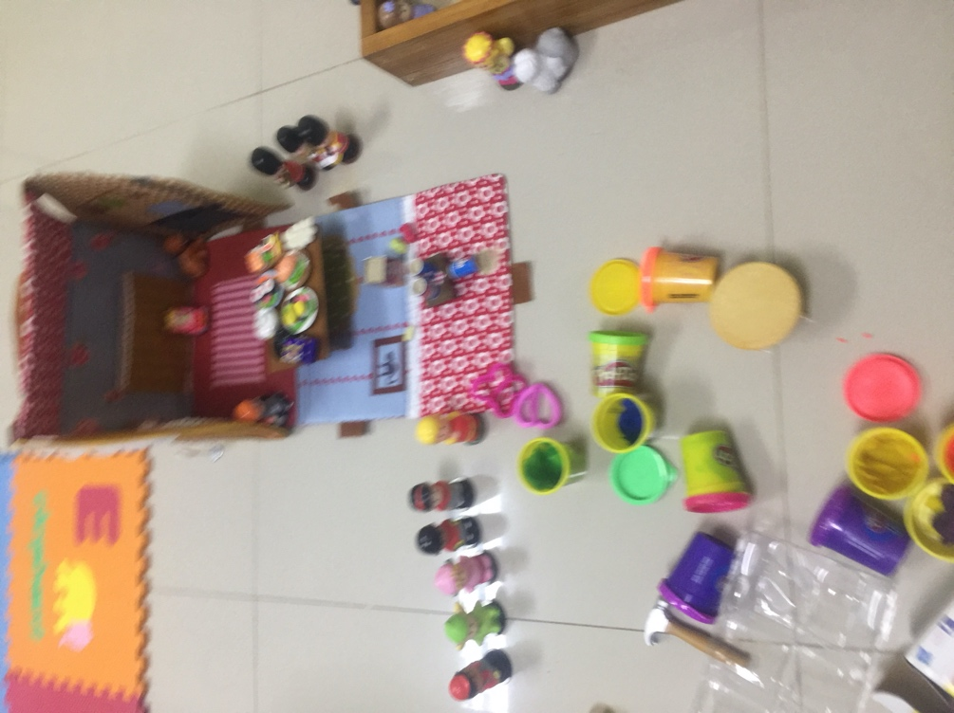

In picture 2 it is shown that ANA chose several human figurine, British Castle Guard figurine, and food. She also picked table and house. She also made some “food” from playdough. While playing with the figurine ANA build a storyline. The storyline is pretty similar with what she told me when she drew the castle on the fifth session. There is a beautiful huge castle where everyone can come for a ballroom dance party. In that castle lives a princess that tortured to clean and cooked everyday by the evil stepmother and stepsisters. This pretty similar storyline also emerged on other sessions but she might chose a different types of figurine. Sometime she develop the storyline with more conflict on it. For example, in one of the session she picked several princesess figurines and those princesses were having a fight to gain the attention of the prince.

Picture 3
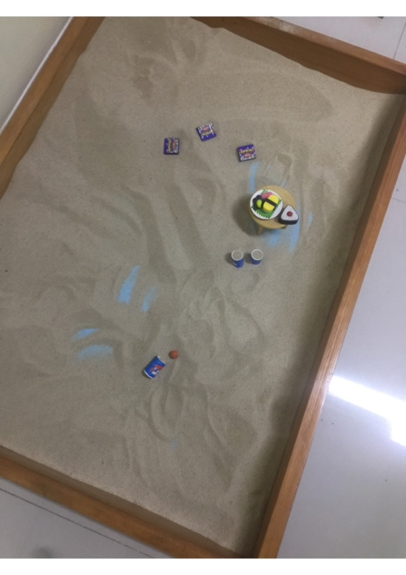
Picture 3 showed ANA activity in session 13th. She still chose the same storyline while playing: Ballroom dance party. But this time she chose to put the food in the sandtray. Some of the food are buried in the sand because there were a fight between the princesses in order to get attention of the prince.
These activities gave therapist more information on ANA. The metaphor she chose mostly related with family, disagreement, and food. In some cases food is a metaphor that chose to reflect the nurturing needs of a client. In ANA case this might exist because the absence of a mother figure in her daily life. Her Mom is there, taking care of her, but not completely there. This condition is acknowledge by her mother on the pre session interview. She mentioned that she frequently felt overwhelmed for taking care of ANA. The mother cannot identified why she felt that. ANA’s Mom suspected that it might be because of ANA’s behavior that she cannot cope with. But the father also mentioned, probably because bot the parents did not expecting to have another child. So both of the parents are not ready to go back to infanthood. The family figurine and the act of disagreement ANA chose might reflect her daily life that full of family affair which usually full of argumentation. From the pre session interview, ANA has to join the daily family ritual before sleeping at night. Everyday this family will connected through video conference to chit chat and praying together with her brothers that live in Japan and Bandung.
Other uncertainty reduction process that ANA chose is through drama or roleplay. In almost all session she always open her special time playing in the room by doing a roleplay. The most frequently chosen roleplay is the supermarket and hairdresser scene. In all roleplay, she always acting as the dominant character. Sometime she became a mean supermarket staff. Another time she became a nasty hairdresser that correcting the consumer looks that she thought as not pretty. Or she might chose to be an angry mother who is very occupied with many activities and got angry with the supermarket or beauty parlour staff.
ANA will widened her eyes and raise her voice when her roleplay partner did not act like what she wanted. When I reflect and said, “I hear ANA raise the voice and widened the eyes as if its gonna fall out,” ANA woul act even more angrier. But what is interesting is that, after the roleplay finished and she chose another tool to play, ANA will became calm and play normally.
Based on the roleplay therapist can get more information and raising certainty towards ANA. In this activity, ANA might be a girl that need a warm, motherly figure to comfort her. Therapist suspected that she frequently saw an adult around her acting like what she did when she do the roleplay.
In Client ANA case the uncertainty reduction process comes in 3 from: Arts, sandplay and figurine, and roleplay. Based on the findings in play and creative arts therapy sessions uncertainty reduction most likely will happen through nonverbal message and the chosen of metaphor by client. Compare to other interpersonal communication settings, in therapy room the uncertainty reduction process will take much longer time. In other interpersonal activities probably by first meeting, sender-receiver can reducing the uncertainty level. Self disclosure in other interpersonal activities also might occur easily because both sender-receiver can asking and answering question consciously. In play and creative arts therapy the question and answer process for reducing uncertainty cannot be trusted. Because this therapy method believe that using metaphor is a lot more effective to communicate and explore client’s emotional, mental, and social condition.
It is important for therapist to be aware that understanding a metaphor is a hard and might be subjective process. In order to build a good understanding on the client, a therapist needs to gain more knowledge on the background of the client, equip with more understanding on universal metaphor, and practicing reflect when accompanying client in the session. In ANA case because the parents are very open so it is quite easy to understand the metaphor ANA chose. For example, to understand why she drew all her windows with grid and gave marks to the drawing is not that hard to tell the reason why. Because ANA’s parents admit that ANA frequently said that she feels lonely, hard to catch up at school, and not happy because there are too many rules in the house and at the school. Therapist understanding on the universal metaphor (in ANA case: food and the needs of nurture) helps a lot to understands ANA better. Reflecting on what client did or what the therapist might see, hear, and feel is also crucial. If I did not reflect when ANA looked nervous when she forgot to marked her drawing, I might not realize that frequently being judge is what ANA feels.

CONCLUSION

Uncertainty reduction in any interpersonal relations is very important. In the case of play and creative arts therapy (especially in Client ANA case), the reduction process occur through nonverbal message and metaphore the client chose. In ANA case, the uncertainty reduction happen through arts activity, sandplay, and roleplay. This might be differ from one client to another, since this therapy method gave independence on every client to choose what he/she want to do. Compare to other interpersonal communication activities, in play and creative arts therapy the uncertainty reduction process can take much longer time. This is normal and explainable since one of the pronciples of this therapy method to understand that client always has an independence to choose an the therapist need to give the client time to process. It is very important to notice that understanding message through nonverbal cues and metaphor is not as easy as when we conduct communication through question and answer in conscious state of mind. Every therapists need to not judge a nonverbal cues or metaphor only by one act. This what makes the uncertainty reduction takes a longer time because we need to follow each session carefully and find consistency then we can conclude. In ANA case, if the client not choose the same storyline over and over again, I might not conclude that what she needs is a nurture adult as her primary caregiver. And this conclusion can be done after more that ten sessions.

REFERENCES

Axline, V. (1981). Play Therapy. Ballantine Books. New York.

CAE. (2021). Apa itu Play Therapy? https://www.cae-indonesia.com/article-detail/54/apa-itu-play-therapy
Craig Haen (2020) The Roles of Metaphor and Imagination in Child Trauma Treatment, Journal of Infant, Child, and Adolescent Psychotherapy, 19:1, 42-55, DOI: 10.1080/15289168.2020.1717171.

Littlemore, J., & Turner, S., (2019) . What Can Metaphor Tell Us About Experiences of Pregnancy Loss and How Are These Experiences Reflected in Midwife Practice? Frontiers in Communication. Volume 4 – 2019. https://doi.org/10.3389/fcomm.2019.00042
Mills, JC. Crowley, RJ. (2014). Therapeutic Metaphors for Children and the Child Within. Routledge. New York.
Nardon, L., Hari, A., (2021). Sensemaking Through Metaphors: The Role of Imaginative Metaphor Elicitation in Constructing New Understandings. International Journal of Qualitative Methods. Volume 20: 1–10. https://doi.org/10.1177/16094069211019589
Santrock, JW. (2011). Child Development. McGraw-Hill. New York.
Solomon, D. Theiss, J. (2013). Interpersonal Communication Putting Theory Into Practise. Routledge. New York.

Stewart, M., & Ryan, SJ., (2020). Do Metaphors Have Therapeutic Value for People in Pain? A Systematic Review. Pain and Rehabilitation - the Journal of Physiotherapy Pain Association, Volume 2020, Number 48, December 2019, pp. 10-23(14). https://www.ingentaconnect.com/content/ppa/pr/2019/00002020/00000048/art00003#
West,R. Turner, L. (2010). Introducing Communication Theory Analysis and Application. McGraw-Hill. New York.
Zatloukal, L., Žákovský, D. & Bezdíčková, E. Utilizing Metaphors in Solution-Focused Therapy. Contemporary Family Therapy 41, 24–36 (2019). https://doi.org/10.1007/s10591-018-9468-8

