Emotional Expression Of Public Communication In Post COVID-19 Era: Educational Context

Author¹, Author², Author³

^{1,2,3} Author's affiliation/institution , City, Country
* author@gmail.com

Article  Submitted: xx-xx-20xx  Reviewed: xx-xx-20xx  Accepted: xx-xx- 20xx  Published: xx-xx-20xx  DOI:  https://doi.org/10.32509/  This work is licensed under a Creative Commons Attribution-NonCommercial-ShareAlike 4.0.  Volume :  No. :  Month :  Year :  Page : | Abstract  This research aims to examine the emotional expression of nonverbal communication performed by scholars during presentations as a post-pandemic public communication practice. In the age of globalization, one of the necessary talents is public communication. A presentation that tries to transmit knowledge about a topic to the audience effectively is a familiar public communication technique scholars perform. Building a connection with the audience is one way to create effective communication, one of which is emotional expression in the form of nonverbal communication through gestures and microexpressions. Public communication skills have deteriorated, particularly during the COVID-19 epidemic, as have emotional expressions in nonverbal communication. With the theoretical perspectives of Baden Eunson (2015) for gestures and Monika Dubey and Lokesh Singh (2016) for microexpression, this study employed a quantitative-descriptive content analysis technique with categorical analysis units. Researchers examined 49 video recordings of scholars’ presentations from February to March 2023. The study's findings revealed that when scholars practiced public communication in class, they employed scared emotions for gestures and calm emotions for microexpressions. This study suggests the significance of public communication training or coaching, particularly for nonverbal emotional displays in presentations, to fulfill communication goals.  Keywords: non-verbal communication; public communication; emotional expression; presentation; COVID-19 pandemic  Abstrak  Penelitian ini bertujuan untuk melihat ekspresi emosional komunikasi nonverbal yang dilakukan oleh mahasiswa pada saat presentasi sebagai praktik komunikasi public pada paska pandemi. Komunikasi publik merupakan salah satu kemampuan yang harus dimiliki di era globalisasi. Praktik komunikasi public yang sering dilakukan mahasiswa adalah presentasi yang bertujuan untuk menyampaikan informasi tentang suatu topik secara efektif kepada audiens. Komunikasi efektif dapat dicapai dengan membangun koneksi dengan audiens salah satunya dengan ekspresi emosional dalam bentuk komunikasi nonverbal baik melaui gestur dan microexpression. Kemampuan komunikasi public mengalami penurunan khususnya saat pandemi COVID-19, termasuk ekspresi emosional dalam komunikasi nonverbal. Penelitian ini menggunakan mentode analisis isi kuantitatif-deskriptif dengan unit analisis kategorial. dengan perspektif teori Baden Eunson (2015) mengenai gestur serta Monika Dubey & Lokesh Singh (2016) untuk microexpression. Peneliti melakukan analisis terhadap 49 rekaman video pada kegiatan presentasi mahasiswa selama periode Februari-Maret 2023. Hasil penelitian menujukkan mahasiswa dalam melakukan praktik komunikasi public di kelas menggunakan emosi takut untuk gestur sebaliknya menggunakan emosi tenang untuk microexpression. Penelitian ini memberikan rekomendasi pentingnya pelatihan atau panduan komunikasi publik terutama tentang ekspresi emosional nonverbal dalam presentasi guna mencapai tujuan komunikasi.  Kata Kunci: komunikasi non-verbal; komunikasi publik; ekspresi emosional; presentasi; pandemi COVID-19

INTRODUCTION
Public communication is described as the process of conveying knowledge from one person to many individuals (West & Turner, 2017). Nowadays, public communication is something that all persons who wish to enter the world of work, including scholars, must study since it may help grow careers, enhance job abilities, and get more respect in the world (Angeline, 2020; Novaković & Teodosijević, 2017). Good public communication allows an individual to demonstrate originality, critical thinking skills, leadership qualities, tranquility, and professionalism, all of which are highly valued in the workplace. Speaking at conferences regularly will help boost an individual's reputation on a job CV (Angeline, 2020). Public communication is frequently carried out by scholars in the classroom when giving presentations in front of the class (Nurzal, 2020).
The goal of a presentation is to effectively transmit knowledge about a topic to the audience (Zainal, 2022; Mufanti et al., 2017). This may be accomplished through emotional expressions while speaking since using emotions when talking can improve the message, boost credibility, and build trust between the communicator and his audience (Shaw, 2015). There are numerous recognized emotions in emotional expression, but in general, six emotions are used as universal emotions: anger, surprise, disgust, happiness, sadness, and fear (Ekman, 1972). However, as time passes, the evolution of emotion categorization causes the classification of emotions to expand, one of which is the addition of calm emotion (Russell, 1989).
Emotional expression in communication can take several forms, including verbal and nonverbal communication (Dubey & Singh, 2016). However, emotional expression in nonverbal communication, defined as any messages or communication signals that are not words or do not employ words (DeVito, 2011; Chotimah, 2015), is a critical facet of communication, particularly when transmitting emotions. According to experts in the field of interpersonal communication, 70% of a person's communication is nonverbal, with just 30% including verbal communication, making the influence of nonverbal communication on someone's acceptance 80% (Hull, 2016). Furthermore, Gerald L. Manning, Barry L. Reece, and Michael Ahearne discovered in their book that things that the communicant typically pays attention to when someone communicates are 7% words (verbal communications), 38% sound (volume, intonation, speed of sound), and 55% body movements and facial expressions (2013). As a result, nonverbal communication is one of the most significant factors evaluated when someone communicates, particularly in public communication. Body cues (gestures and body postures) and facial expressions are the most essential nonverbal communication in emotional expressions (Andersen & Guerrero, 1998).
However, the COVID-19 (Coronavirus disease) pandemic, which erupted in early January 2020, has affected many areas of human existence, including emotional expression in nonverbal communication. According to a previous study, "Changes in Nonverbal Communication in Public Communication Before and During the COVID-19 Pandemic: Literature Review of Scientific Papers for the 2014-2022 Period," using a mask covering the lower and middle part of the face makes it more difficult for a person to understand nonverbal facial signs (Sutanto et al., 2022).
Aside from that, internet communication, which is thought to be more effective and safer during the COVID-19 epidemic, complicates communication flow. According to a research conducted by Real, Carandang, Contreras, and Diokno on 287 scholars of the Philippine School Doha 2020-2021 Junior High School, 78% (nearly always) pupils acknowledged that they bowed unknowingly when explaining something to the class when online classes took place (2021). This habit is a negative technique in online public communication because it gives the idea that the communicator is fearful, which is not often the case (John et al., 2017). This eventually leads to a misunderstanding of sentiments, where the communicator does not necessarily feel fearful but is seen as such by the audience.
This undoubtedly affects the appearance of scholars in Indonesia who have finished around 1.5 years of Senior High School or online college. This set of scholars was obliged to deliver presentations in class online or wear masks throughout this period. Even if the COVID-19 epidemic has been more controlled and learning activities have been conducted face-to-face, it is still possible that COVID-19 has impaired nonverbal emotional expression abilities. A previous study has described changes in nonverbal communication of gestures and microexpressions in public communication before and during the COVID-19 pandemic and the influence of COVID-19 on nonverbal communication of gestures and microexpressions in public communication. However, no study has been conducted to determine if this influence would persist long after the COVID-19 epidemic has ended and all activities have returned to normal. As a result, researchers are interested in investigating this. Research findings can give an overview of scholars' nonverbal emotional expressions and information on whether emotional expressions of nonverbal communication at the higher education level need to be improved and what type of improvements are expected.
Researchers outline five key concepts to explain public communication and its link to nonverbal communication: emotional expression, gesture, and microexpression. West and Turner (2017) defined public communication as the process of conveying knowledge from one person to many individuals. As previously said, public communication by scholars is typically in the form of a presentation. The presentation falls under the category of informative speech, which attempts to educate and enlighten the audience about a topic (Mufanti et al., 2017). This may be accomplished by showing emotional expressions while speaking since using emotions when talking can strengthen the message, boost credibility, and build trust between the communicator and his audience (Shaw, 2015).
The second concept is nonverbal communication, which is defined as communication in which the message is packed in nonverbal or stimulus form, without the use of words created by the individual and the use of the environment by the individual that has potential for the sender or recipient (Samovar & Porter, 1991). Another definition indicates that nonverbal communication is the purposeful or inadvertent conveyance of information between two or more individuals without speech or writing (Azemi, 2021).
The third is emotional expressions, which are derived from feelings. Emotion is defined as internal mental states that are concentrated due to influence (Ortony et al., 1987). The primary notion stressed in this definition is that emotions are created internally rather than externally. Second, emotions are physiological, cognitive, or behavioral states (Ortony et al., 1987). Emotions can originate from a stimulus from inside or outside of the individual. Individual physiology and cognition are also linked to emotions (Prawitasari, 1995). There are many different types of emotions acknowledged. However, in general, there are six universal emotions (basic emotions) that are used: anger (angry), surprise (surprised), disgust (disgust), happiness (happy), sadness (sad), and fear (fear) (Ekman, 1972). However, as time passes, the evolution of emotion categorization causes the classification of emotions to expand, one of which is the addition of calm emotions (Russell, 1989). A person's emotions will generate an internal reaction triggered by an emotional stimulus. These are known as emotional experiences (Andersen & Guerrero, 1998). People frequently express their emotional experiences regarding how pleased or dissatisfied they feel in reaction to a stimulus. This is accomplished through the interpersonal expression of these emotions, which are called emotional expressions (Andersen & Guerrero, 1998).
The fourth is a gesture with meaning as a kind of nonverbal communication with bodily motions that express specific messages, either as a substitute for vocal communications or in conjunction with verbal messages (Priyadharshni, 2014). In practice, gestures can convey feelings or mental states (Eunson, 2015). The fifth is microexpression, which is described as a facial expression that is visible for only a few seconds (1/15-1/25 second) and may be used to reveal someone's genuine, concealed feelings (Li et al., 2021).

METHOD
This study used a descriptive quantitative content analysis approach with a categorical distinctions analysis unit. Quantitative research is based on positivism, used to analyze specific populations or samples, collect data using research instruments, and evaluate data as quantitative or statistical to test a predetermined hypothesis (Sugiyono, 2017, p.14).
This study examined video recordings of scholars' public communication behaviors at a private university in Surabaya that has been attending online classes for over two years. Scholars had just recently begun face-to-face classes when the research data was collected. The goal of this study is to examine the component of emotional expression demonstrated by nonverbal communication movements and microexpression in public communication (presentation) using the theories of Baden Eunson (2015) and Monika Dubey & Lokesh Singh (2016).
Data was collected via recording scholars’ presentations during February-March 2023 (after COVID-19). The researcher then utilized a complete sampling strategy in which the entire population was used as a sample (Sugiyono, 2017). According to Roscoe, the optimal sample size for the study is between 30 to 500 (Sugiyono, 2017). This study's sample size was 49 people. One sample was a recorded video that lasted between 3 and 9 minutes.
Furthermore, content analysis was carried out using seven emotional indicators, namely anger, surprise, disgust, happiness, sadness, fear, and calmness, each with its classification of gestures and microexpressions. The tool for measuring emotional gesture expression was from Baden Eunson's 2015 book 'Communicating in the 21st Century, 4th Edition'. Meanwhile, the microexpression measuring instrument was from a published journal entitled 'Automatic Emotion Recognition Using Facial Expression: A Review' by Monika Dubey and Prof. Lokesh Singh in 2016.

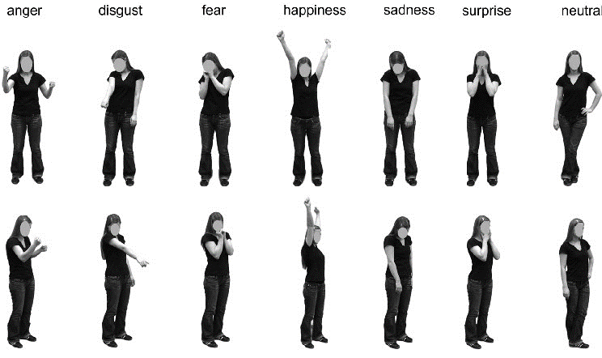
Figure 1. Gesture and Emotion Chart
(Source: Thoma, Bauser, & Suchan, 2012)
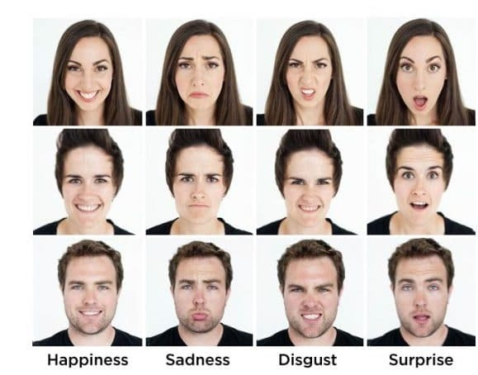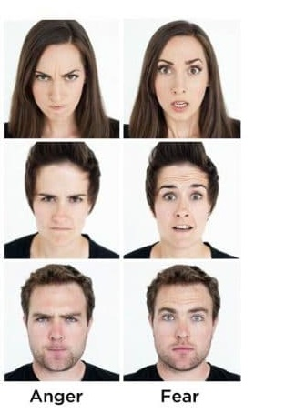
Figure 2. Microexpression dan Emotion Chart
(Source: Edwards, V. V. n.d.)

The indicators and sub-indicators are explained in further depth below:
- Angry emotion in the aspect of emotional expression is shown by upright and stiff body posture (GA1), shoulders up (GA2), fists clenched (GA3), arms crossed (GA4), both hands on hip (GA5), pointing fingers (GA6 ). Microexpression of angry emotions is shown by eyebrows lowered and drawn together (MA1), hard stare (MA2), rolling eyes (MA3), and tightly closed lips (MA4).
- Surprised emotions in emotional expression are gestures shown by the body being erect but pulled back momentarily (GSu1) and hands being raised to the face or head (GSu2). Microexpression of surprise is indicated by raised and curved eyebrows (MSu1), jaw drops without widening of the mouth (MSu2), and eyes wide open with the white of the eye showing above and below (MSu3).
- Disgust emotion in the aspect of emotional expression is indicated by a tilted body posture and pulled backward (GD1), downward head tilt (GD2), and arms raised with straight forearms (GD3). Microexpressions of disgust are indicated by downward-drawn eyebrows (MD1), nose wrinkles (MD2), and raised upper lips (MD3).
- Happy emotions in the aspect of non-verbal communication in gestures are shown by an upright body posture facing the audience (GH1), straight shoulders (GH2), and hands raised upwards (GH3). Happy microexpressions are shown by making constant eye contact (MH1), mouth open with teeth showing (MH2), corners of lips turning upwards (MH3), cheeks lifting (MH4), and wrinkles around the eyes (MH5)
- Sad emotions in non-verbal communication aspects of gestures are shown by hunched and collapsed postures (GSa1), slouched shoulders (GSa2), head down (GSa3), hands covering the face (GSa4), hands hanging in front of the body (GSa5). Microexpression of sad emotions is shown by the inner corner of the eyebrows being drawn in and then up (MSa1), eyes closed for a long time (MSa2), and lip corners being pulled down. (MSa3).
- Fear emotions in aspects of non-verbal communication in gesture, indicated by collapsed and stiff posture (GF1), frequent body movements (GF2), hands holding certain body parts for no reason (GF3), hands holding hair (GF4), and hands holding and playing with an object for no reason (GF5). Microexpressions of fear are shown by refusing eye contact (MF1), eyebrows raised and drawn in an even line (MF2), and mouth slightly open with tense lips (MF3).
- Calm emotions in the non-verbal communication aspect of gestures are shown by an open posture (GC1), hands next to the body and calm (GC2), and one hand placed on the waist (GC3). Microexpressions of calm emotions are indicated by straight eyebrows (MC1), slack cheeks (MC2), and flat lips (MC3).
Furthermore, to verify the validity and reliability of this research. The researchers also examined the validity and reliability. The validity test used was the face validity of Klaus Krippendoff (2004). Researchers reviewed journals and books on research to see whether the measuring equipment utilized is approved and valid. While the Klaus Krippendorff (2004) formula was used for the reliability test, the following formula was used:
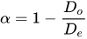
Reliability =

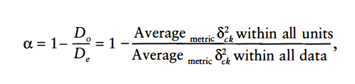
Description:
α = Krippendorff's alpha coefficient
Do = Observed disagreements
De = disagreements that can be expected when the opportunity arises
According to Krippendorff, the second requirement for a coder is cognitive ability (the ability to pay attention to detail consistently), a clear understanding of the technicalities of the analysis being performed, and having the same background, experience, or understanding as the material to be studied (Krippendorff, 2004). The researcher had chosen a second coder who met the abovementioned criteria.

RESULTS AND DISCUSSION (Calibri body 11pt)
Researchers (coder 1) and coder 2 coded 15 samples that had descriptions of emotional expressions shown in nonverbal communication, gestures, and microexpressions in public communication from the 49 units of the population tested (around 30%). Next, in calculating reliability, researchers used the IBM SPSS Statistics 26 program and added the kalpha.sps plug-in from the website of Andrew F. Hayes, Ph.D. (http://afhayes.com/spss-sas-and-r-macros-and-code.html).

Table 1. Reliability Test Calculation Results
Emotion (Indicators) | Gesture  (Sub-indicators) | Krippendorff’s α | Microexpression  (Sub-indicators) | Krippendorff’s α
Anger | GA1 | 0,8199 | MA1 | 0,7411
Anger | GA2 | 0,8199 | MA2 | 0,8612
Anger | GA3 | 0,768 | MA3 | 1
Anger | GA4 | 1 | MA4 | 1
Anger | GA5 | 1
Anger | GA6 | 0,7315
Surprise | GSu1 | 0,8466 | MSu1 | 0,8688
Surprise | GSu2 | 1 | MSu2 | 1
Surprise |  |  | MSu3 | 0,768
Disgust | GD1 | 0,7411 | MD1 | 1
Disgust | GD2 | 0,71 | MD2 | 0,8199
Disgust | GD3 | 1 | MD3 | 1
Happiness | GH1 | 0,71 | MH1 | 1
Happiness | GH2 | 0,768 | MH2 | 1
Happiness | GH3 | 0,8466 | MH3 | 1
Happiness |  | 0 | MH4 | 0,71
Happiness |  |  | MH5 | 1
Sadness | GS1 | 1 | MS1 | 1
Sadness | GS2 | 0,8612 | MS2 | 1
Sadness | GS3 | 0,7315 | MS3 | 1
Sadness | GS4 | 1
Sadness | GS5 | 1
Fear | GF1 | 1 | MF1 | 0,8466
Fear | GF2 | 0,7411 | MF2 | 0,768
Fear | GF3 | 0,8466 | MF3 | 1
Fear | GF4 | 1 |  | 0,8688
Fear | GF5 | 0,8688
Calmness | GC1 | 0,7315 | MC1 | 1
Calmness | GC2 | 1 | MC2 | 1
Calmness | GC3 | 1 | MC3 | 1
Source: Research Results, 2023

According to the data in Table 1, each gesture and microexpression sub-indicator achieved a figure above 0.6 or moderate reliability for 13 sub-indicators, while 38 additional sub-indicators achieved a figure above 0.8 or high reliability. In the Krippendorff formula, these two coefficient numbers were greater than the minimal reliability coefficient. As a result, the coding sheets created in this study were reliable.
The researcher performed a validity test in addition to the reliability test. Face validity was employed in this study to determine how effectively a measuring instrument clearly and sensibly conveys information and correlates it with current data (Krippendorff, 2004). As a result, researchers assessed by reviewing books and periodicals arranged by the scientific field community under investigation. All of the sub-indicators of emotional expression, gestures, and microexpressions were discovered to be reliable measuring techniques.

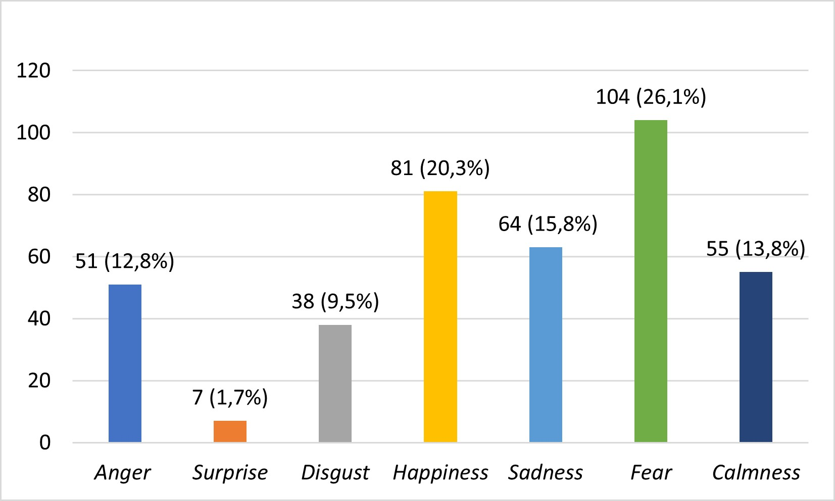
Figure 3. Emotional Expression (Gesture) Results
(Source: Research Results, 2023)

According to Figure 3, the most common emotional expressions in the form of gestures shown by scholars in most presentations were fear gestures, which appeared 104 times (26.1%), followed by happiness gestures, which appeared d 81 times (20.3%), then sad gestures that came out 64 times (15.8%), then calm gestures that appeared 55 times (13.8%), followed by angry gestures that showed up 51 times (12.8%), then disgust gestures that were seen 38 times (9.5%), and the gestures of surprise happened 7 times (1.7%).
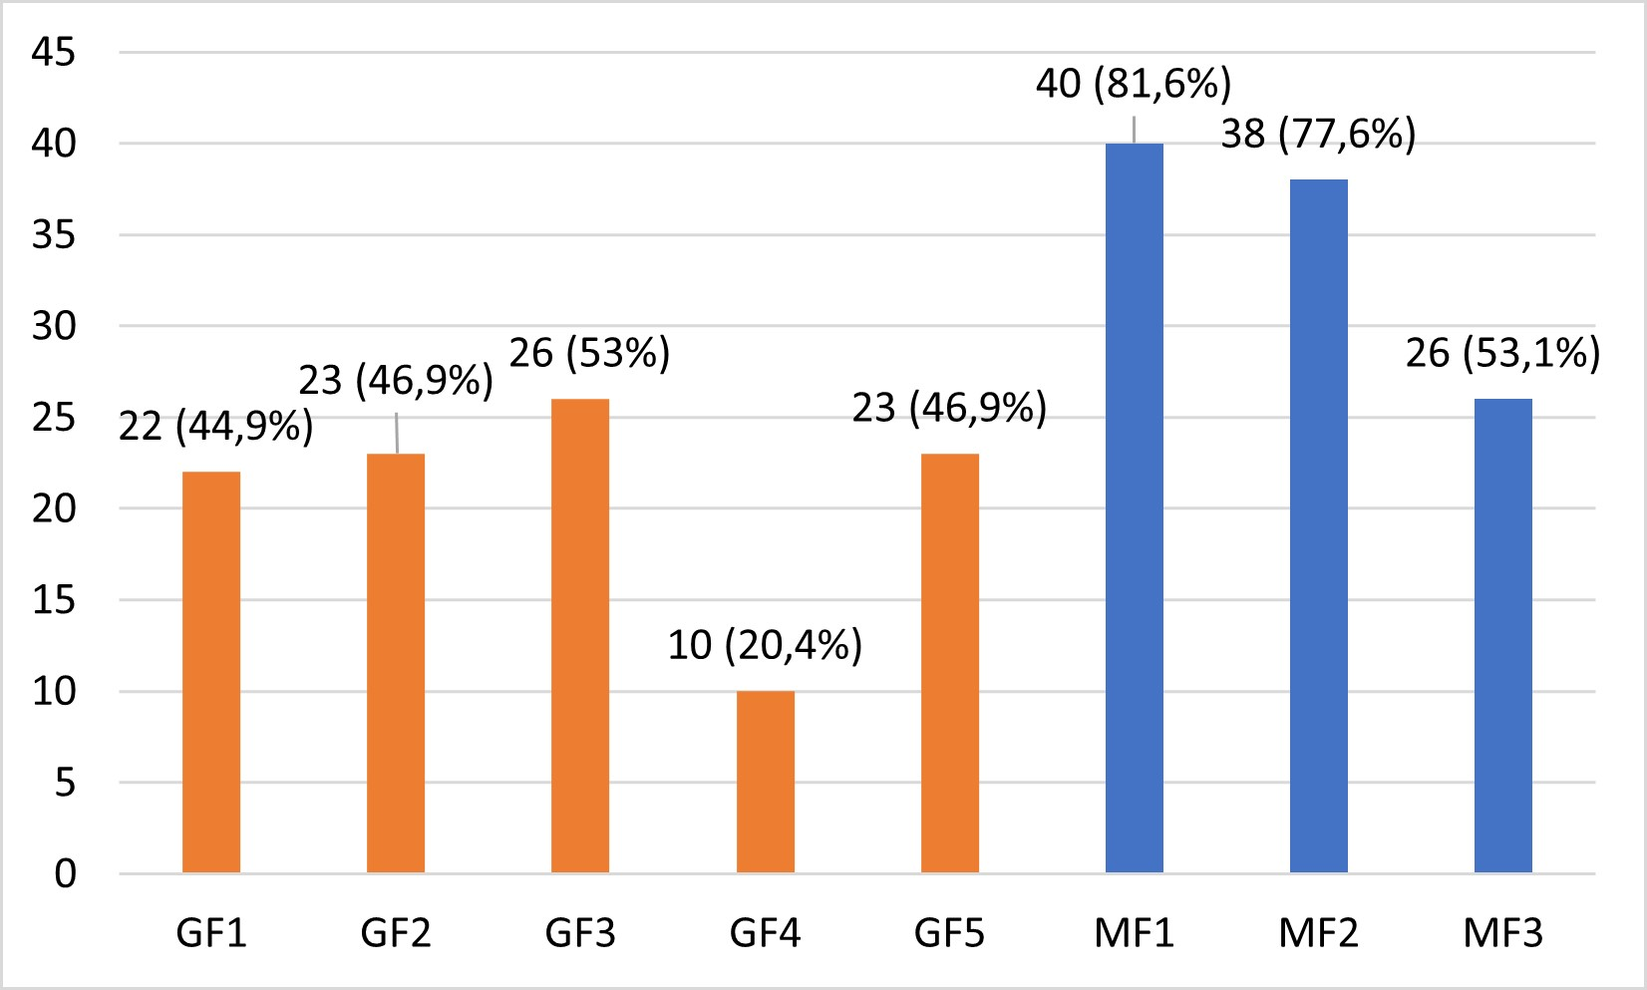
Figure 4. Emotional Expression (Fear) Results
(Source: Research Results, 2023)

As shown in Figure 3, the most emotional expression in the form of gestures made by scholars in presentations was the emotional gestures of fear, which appeared 104 times (26.1%). These emotions included gestures GF1, GF2, GF3, GF4 and GF5. It can be concluded from Figure 4 that the gesture most frequently shown by scholars is GF3.
Fear is an emotion triggered by danger. Fear might happen due to physical or mental injury. Nervousness, panic, anxiety, and concern are secondary emotions of fear (Dubey & Singh, 2016). Fear is one of the active-negative emotions identified in Russell's 'The Circumplex Model' (1989). During the COVID-19 pandemic, fear gestures may occur due to the pandemic's effect. The COVID-19 pandemic -19, according to Bob Abernethy, a public speaking specialist and author of the book 'Love Your Audience: How to Conquer the Anxiety of Public Speaking,' has explained the correlation between one's anxiety and public communication. He stated that anxiety will eventually impact a person's ability to communicate effectively in public (2016). This is evident in the presentation behaviors of research scholars, where the most common movements displayed during presentations are those of anxiety. Several additional studies came to the same conclusion, including one by Alison C. McLeish, Kandi L. Walker, and Joy L. Hart, who assessed anxiety levels in 568 scholars from all nations over 18. According to this study, scholars reported 12.3% more social anxiety or dread while speaking in public in 2021 than in 2020, before the COVID-19 pandemic. This occurred because of the COVID-19 epidemic, which shifted the scholars' education system from on-campus to online classes, making students rarely exposed to public communication and increasingly afraid of practicing public communication (2021).
Furthermore, a study conducted in India by Gal Arad, Dana Shamai-Leshem, and Yair Bar-Haim that examined social anxiety or feelings of fear displayed when speaking in public by 99 Tel Aviv University scholars discovered that one year after regulations for online teaching and learning were removed, scholars' social anxiety gradually decreases but still appears in student public communication (2021). This is also consistent with the results of researchers, who discovered that after the COVID-19 epidemic, the most common gesture made by scholars during presentations was fear gestures, which might be attributed to the influence of COVID-19. Due to changes in the education system, specifically from the on-campus teaching-learning process to going online, scholars were rarely exposed to public communication. They eventually became increasingly afraid of practicing public communication after the pandemic, which continues to affect scholars’ public communication to this day.
These fear expressions should be avoided in presentation. Some experts say fear is a negative feelings (Leung & Chan, 2022; Grundmann et al., 2021; Plutchik, 1980). This occurs because when a communicator in public communication displays an emotion of fear, such as the GF3 gesture and other gestures, the audience will catch this expression. A communicator who constantly displays anxiety will appear foolish and ineffective in conveying his message to the audience (Andersen & Guerrero, 1998). Furthermore, the gestures of GF3, GF4, and GF5 are included in self-soothing or pacifying behaviors that communicators often use to calm down when they are nervous (Navarro, 2008). This will lead the audience to be distracted, apprehensive, less focused on the message, and bored and hesitant to listen to the communicator (Real et al., 2020). Furthermore, the audience may feel apathetic and avoid the communicator (Boynukara, 2019).
As a result, the message will not reach the intended audience. Of course, this is incompatible with the goal of presentation as public communication, which is to successfully transmit a message about a topic to the audience by creating a good relationship or trust with the audience (Zainal, 2022; Mufanti et al., 2017). Aside from that, if the communicator shows this expression to the audience, it may make the audience uncomfortable and unable to retain all of the messages communicated by the communicator (Hull, 2016). Hull (2016) stated that public communicators must contain their anxiety and not show it to the audience.
To prove the statements above, in one study, fifty university scholars were asked to choose between two presentations, one featuring a communicator who exhibited numerous confident gestures and facial expressions. On the contrary, in the second presentation, the communicator used fearful gestures and expressions. Consequently, 94% of scholars believed the first presentation would increase their concentration and interest in listening to the communicator's message (John et al., 2017). It may be inferred that in presentation, scholars should avoid showing anxiety through gestures and microexpressions.
Scholars' fearful gestures and microexpressions during presentations will also impede communication engagement. Communication engagement is described as communication to establish collective participation in behavior, cognition, and affection (Johnston & Taylor, 2018). Communicators with fearful expressions during a presentation will disturb the audience, make them nervous, make them less focused on the message conveyed by the communicator, and make them bored and reluctant to listen to the communicator, all of which will reduce the collective cognitive level and cause communication disengagement (Grundmann et al., 2021). When the collective cognitive level is not attained, neither is the collective affective level. It is possible to deduce that scholars who produce fearful expressions during a presentation will diminish the amount of communicative interaction between themselves and the audience. Since this is the most prevalent gesture shown by the scholars in this study, there should be training or public communication standards to limit it.
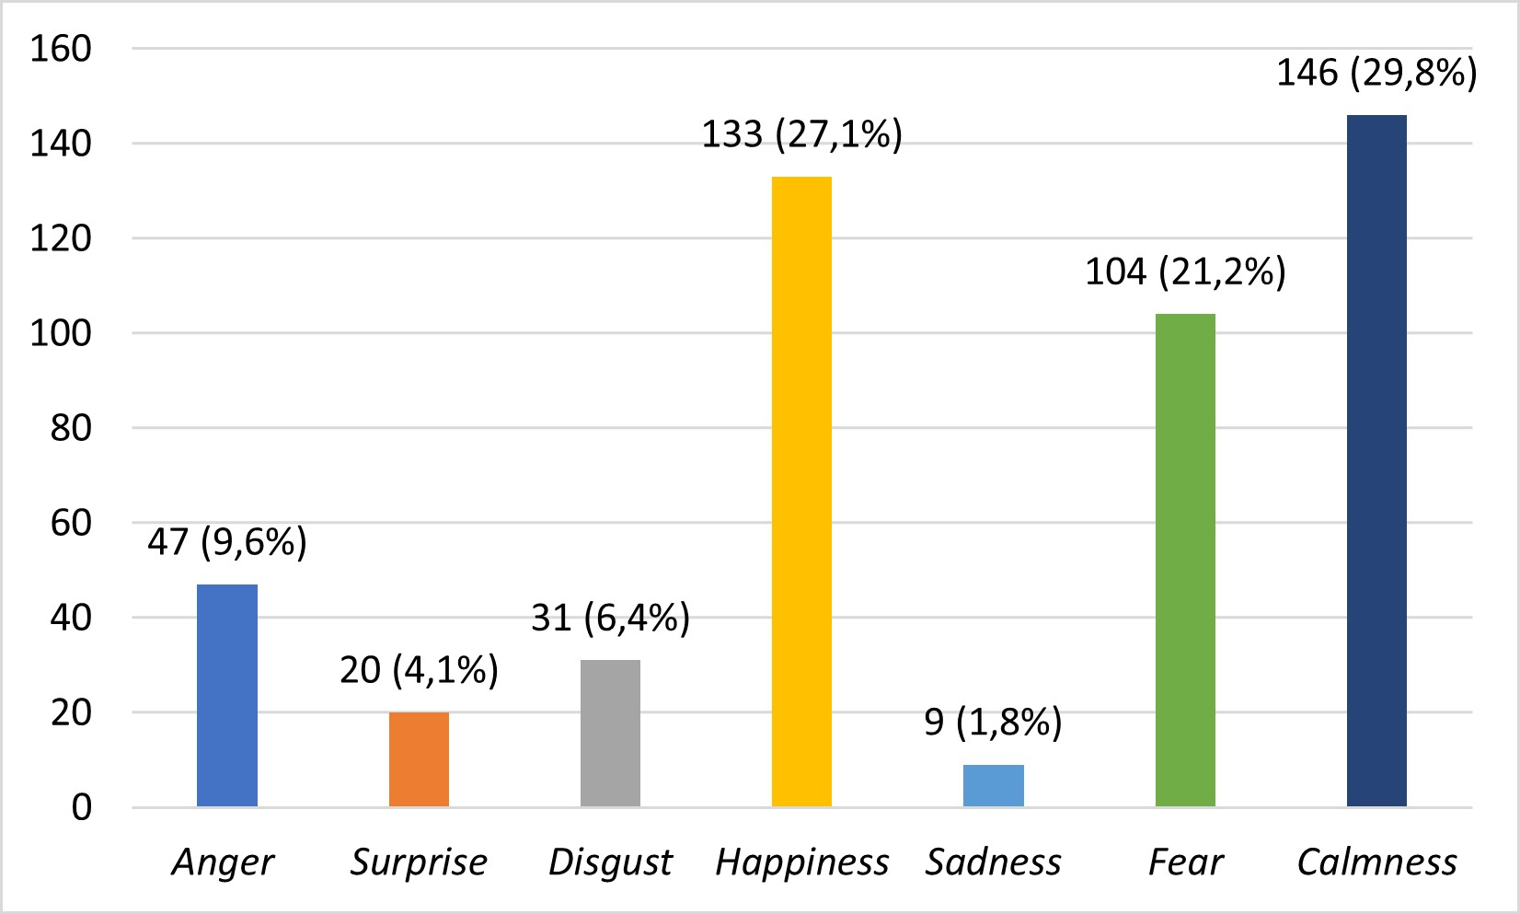
Figure 5. Emotional Expression (Microexpression) Results
(Source: Research Results, 2023)

Based on Figure 5, the most emotional expressions in the form of microexpressions produced by scholars in presentations were calm emotions, which appeared 146 times (29.8%), followed by happy emotions, which appeared 133 times (27.1%), then fear emotions that appeared 104 times (21.2%), then angry emotion which appeared 47 times (9.6%), disgust emotions which appeared 31 times (6.4%), then surprise emotion which appeared 30 times (4.1%), and sad emotional microexpressions appeared 9 times (1.8%).

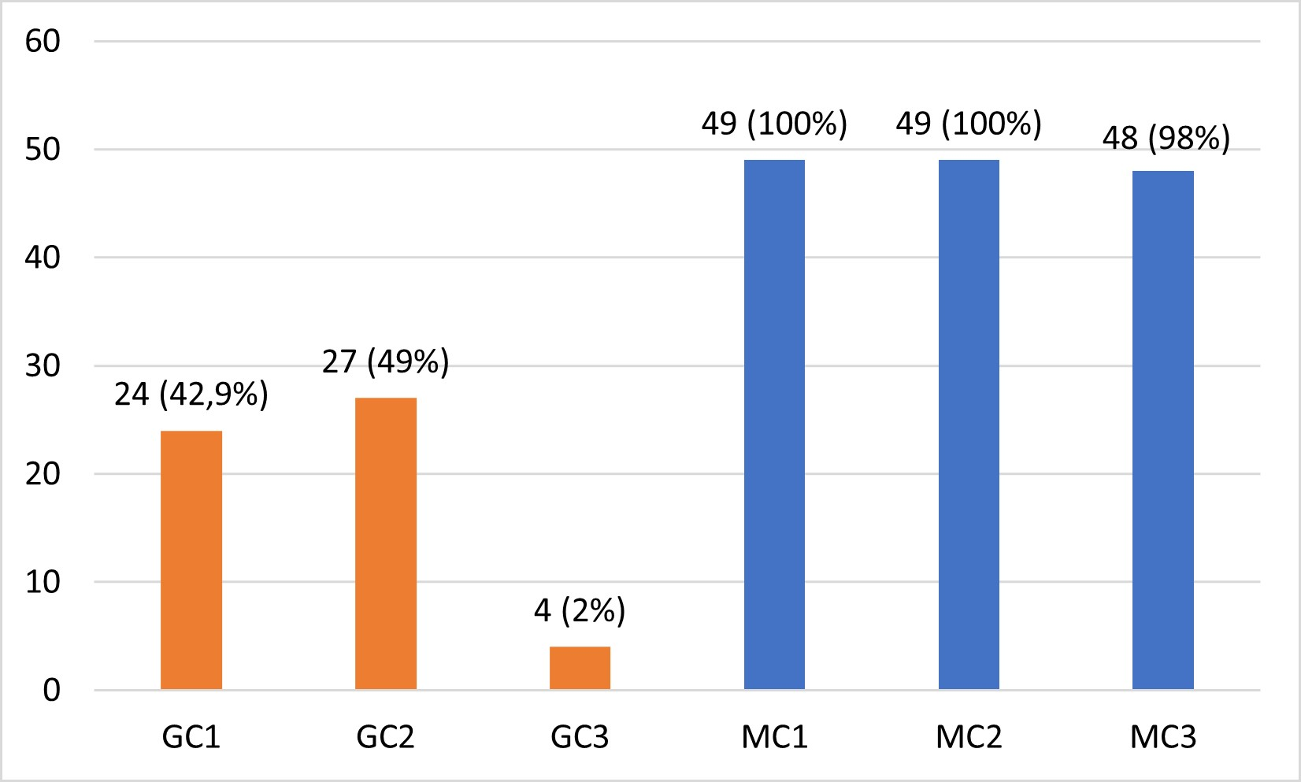
Figure 6. Emotional Expression (Calmness) Results
(Source: Research Results, 2023)

As shown in Figure 5, the most emotional expressions in the form of microexpressions in presentations were calm emotional microexpressions, which appeared 146 times (26.1%). MC1, MC2, and MC3 were examples of these feelings. Based on Figure 6, almost all scholars performed the three calm microexpressions, with 49 (100%) doing MC1 and MC2 and 48 (98%) performing MC3.
Calm is a state of mind when a person is not concerned, upset, nervous, fearful, or terrified. Calm individuals experience tranquility, relaxation, patience, and ease (Russell, 1989). In Russel's ' The Circumplex Model, 'calm is classified as a passive-positive emotion' (1989). The rise in calm microexpressions performed by scholars during presentations may be connected to the COVID-19 pandemic. Previous research titled "Changes in Nonverbal Communication in Public Communication Before and During the COVID-19 Pandemic: Literature Review of Scientific Papers for the 2014-2022 Period" discovered that wearing a mask covering the lower and middle part of the face makes it more challenging to understand nonverbal signs, harder to see a person's expression and conceal the communicator's nonverbal communication (Sutanto et al., 2022). This leads people to lose their ability to communicate emotions or interact with others throughout the pandemic and become expressionless (Have, 2022). This still affects even after the COVID-19 pandemic has ended when scholars show an absence of an expression or calm emotion most of the time while presenting.
Expressing calm nonverbal emotions in conversation too frequently and for extended periods will harm communication. This occurs because the communicator cannot transmit his emotions to the audience if he consistently expresses calm emotions (Schneider et al., 2017). Excellent and suitable emotional expression is the key to an effective presentation since proper expression according to the content will keep the audience engaged and grasp what the communicator is saying (Public Speaking Academy, 2022). The lack of expressiveness will weary the audience and make them hesitant to listen to the communicator's message (Schneider et al., 2017; Andersen, 2004). Furthermore, the appropriate expression and message will explain or reinforce the communicator's spoken message and serve as a manner of connecting with the audience (Andersen & Guerrero, 1998). Using the appropriate expression will increase the audience's trust in the communicator (Andersen & Guerrero, 1998). The communicator will fail to connect with the audience if they do not express themselves, and the message will not be adequately transmitted. In the end, calm emotions can be used during a presentation. However, calm emotions must be followed by other excellent and suitable emotions for the audience to stay engaged in the content and connect effectively with the communicator. Given that many scholars continue to use these microexpressions without being followed by other emotions and for an extended period, it is vital to have training or public communication guides to utilize these microexpressions effectively.
Happiness is a more positive emotional expression to use in a presentation, and it is also one of the six universal emotions by Paul Ekman (1972). Happiness is an emotion that arises when a person feels well-being and contentment (Tamir et al., 2017). Many communication specialists think that only happy emotions are regarded as positive emotions (Plutchik, 1989; Ekman, 1972; Posamentier & Abdi, 2003). This is because happy expressions in communication create the perception of intimacy and emotional connection between the communicator and the person being communicated (Andersen & Guerrero, 1998). When communicating with a pleasant smile, the communicator appears more trustworthy (Li et al., 2021), warm (Wang et al., 2017), and confident (Gao et al., 2016). As a result, communication expert Raymond Hull proposed that communicators modify their thinking to look happy when talking (Hull, 2016).
One piece of evidence is a 2014 study that concluded that in public communication, children over the age of 10 would trust more and have a perception of trust in as much as 50% of their communicators when the communicators use a lot of happy expressions when communicating compared to when they use calm expressions, with only 25% (Caulfield et al., 2014). Furthermore, another study done in 2021 discovered that scholars in China studying public communication saw the communicator as friendlier and more trustworthy the more frequently the communicators used happy emotions in their communication (Li et al., 2021). The friendlier, more confident, and trustworthy a communicator appears in public, the more the audience wants to hear and focus on the message delivered (John et al., 2017). As previously said, this creates a perception of closeness and emotional connection between the communicator and the communicant (Andersen & Guerrero, 1998), which is consistent with the purposes of public communication. As a result, in a presentation, happy emotion is strongly suggested. From a cognitive and affective standpoint, happy expressions will also promote effective communication engagement between the communicator and the audience. The message will be effectively communicated to the audience, and the relationship between the communicator and the audience will strengthen (Grundmann et al., 2021).
Following all of the previous facts and analyses, the COVID-19 pandemic has influenced the course of public communication presentations, particularly among college scholars. Scholars' most emotional expressions were fear gestures and calm microexpressions, which directly resulted from the ongoing COVID-19 pandemic. Given that emotional expression in public communication has a significant impact on communication effectiveness, emotional expression must be recognized and trained so that it can be appropriately controlled in the future, and bad habits of inappropriate emotional expression in public communication presentations must be reduced (Ekman, 2022; Jaskolka, 2012). Communicators who can regulate the presentation of pleasant and appropriate nonverbal emotions according to the message will increase cognitive and affective communication engagement. The message will be effectively communicated to the audience, and the relationship between the communicator and the audience will strengthen (Grundmann et al., 2021).

CONCLUSION
Scholars must be able to express themselves emotionally during presentations. Emotional expression in a good and proper form is critical to practice in presentations for efficacy, successful communication, and audience engagement. On the other hand, people cannot suddenly master emotional expressions, although they must be trained via experience and practice. Scholars' emotional expression abilities have been hampered by the COVID-19 pandemic, which has decreased social engagement. This study's findings showed that due to the COVID-19 pandemic, scholars' nonverbal emotional expression abilities were worsened. Given this, it is vital to give training or develop a training book to teach nonverbal emotional displays in scholars' presentations to decrease these negative emotional expressions.

REFERENCES

Abernethy, B. (2016). Love your audience: How to conquer the anxiety of public speaking. Amazon
Publishing.
Andersen, P. A. (2004). The complete idiot’s guide to body language. ALPHA.
Andersen, P. A., & Guerrero, L. K. (1998). Handbook of communication and emotion: research, theory, application, and contexts. Academic Press.
Angeline, K. G. (2020). Importance of public speaking in the future. Researchgate.net. https://www.researchgate.net/publication/346409575.
Arad, G., Shamai-Leshem, D., & Bar-Haim, Y. (2021). Social distancing during a COVID-19 lockdown contributes to the maintenance of social anxiety: A natural experiment. Cognitive therapy and research, 45(4), 708–714. https://doi.org/10.1007/s10608-021-10231-7.
Azemi, I. (2021). Non-verbal communication in public appearance. International Journal of Arts and Social Science 4(4), 256-267. https://www.ijassjournal.com/2021/V4I4/4146585942.pdf.
Boynukara, H. (2019). Nonverbal communication (body language) and cultural difference.
https://acikbilim.yok.gov.tr/bitstream/handle/20.500.12812/245605/yokAcikBilim_10280091.pdf?sequence=-1.
Caulfield, F., Ewing, L., Burton, N., Avard, E., & Rhodes, G. (2014). Facial trustworthiness judgments in children with ASD are modulated by happy and angry emotional cues. PloS one, 9(5), e97644. https://doi.org/10.1371/journal.pone.0097644.
Devito, J. A. (2011). Komunikasi antarmanusia. Karisma Publishing.
Dubey, M., & Singh, L. (2016). Automatic emotion recognition using facial expression: A review. International Research Journal of Engineering and Technology 3 (2), 488-492. https://www.irjet.net/archives/V3/i2/IRJET-V3I284.pdf.
Edwards, V. V. (n.d.). The definitive guide to reading microexpressions: facial Expressions. https://www.scienceofpeople.com/microexpressions/.
Ekman, P. (1972). Universal and cultural differences in facial expression of emotions. University of Nebraska Press.
Eunson, B. (2015). Communicating in the 21st century. Wiley.
Gao L., Ye M. L., Peng J., & Chen Y. S. (2016). How important are facial appearance to Leadership: A literature review of leaders’ facial appearance. Psychol. Sci., 39, 992–997. https://doi.org/10.16719/j.cnki.1671-6981.20160434.
Grundmann, F., Epstude, K., & Scheibe, S. (2021). Face masks reduce emotion-recognition accuracy and perceived closeness. PLoS ONE, 16. https://doi.org/10.1371/journal.pone.0249792.
Hull, R. H. (2016). The art of nonverbal communication in practice. The Hearing Journal 69(5), 22-24. https://doi.org/10.1097/01.HJ.0000483270.59643.cc.
Jaskolka, A. (2011). The picture book of body language: The only language in which people can’t lie. Foulsham.
John, A. D., Nagarajan, G. & Arthi, M. (2017). Non verbal communication in public speaking. International Journal of Research in Humanities, Arts and Literature, 5(2), 97-100.
Johnston K.A., & Taylor, M. (2018). The handbook of communication engagement. Wiley.
Krippendorff, K. (2004). Content analysis: an introduction to its methodology. Sage Publication.
Leung, C. H., & Chan, W. T. Y. (2022). Lack of teacher facial expression in the COVID-19
pandemic: Problems and ways to solutions. Journal of Asian Scientific Research, 12(2), 62-69. https://doi.org/10.55493/5003.v12i2.4492.
Li, Y., Jiang, Z., Yang, Y., Leng, H., Pei, F., & Wu, Q. (2021). The effect of the intensity of happy expression on social perception of chinese faces. Frontiers in Psychology, 12. https://doi.org/10.3389/fpsyg.2021.638398.
Manning., Reece, B.L., & Ahearne, M. (2013). Selling today (12th ed.). Prentice Hall.
McLeish, A. C., Walker, K. L., & Hart, J. L. (2022). Changes in internalizing symptoms and anxiety sensitivity among college students during the COVID-19 pandemic. Journal of psychopathology and behavioral assessment, 44(4), 1021–1028. https://doi.org/10.1007/s10862-022-09990-8.
Mufanti, R., Gestanti, R. A., & Nimasari, E. P. (2017). Can I be a public speaker: Get ready for speech (2nd ed). Nata Karya.
Navarro, J. (2008). What every body is saying. Harper Collins Publishers.
Novaković, N., & Teodosijević, B. (2017). Basics of public speaking. Bizinfo Blace, 8(2), 33–46.
https://doi.org/10.5937/bizinfo1702033n.
Nurzal, E. R. (2020, Dec 28). Hal terpenting dalam penyampaian pesan presentasi untuk meyakinkan audiens anda. LLDIKTI. https://lldikti6.kemdikbud.go.id/2020/12/28/hal-terpenting-dalam-penyampaian-pesan-presentasi-untuk-meyakinkan-audiens-anda/.
Ortony A., Clore, G. L., & Foss, M. (1987). The referential structure of the affective lexicon.
Cognitive Science, 11(3), 361-384. https://doi.org/10.1016/S0364-0213(87)80010-1.
Plutchik, R. (1980). Emotion: A psychoevolutionary synthesis. Harper & Row.
Posamentier, M. T., & Abdi, H. (2003). Processing faces and facial expressions. Neuropsychology
Review, 13(3), 113- 143. https://doi.org/10.1023/A:1025519712569.
Prawitasari, J. E. (1995). Mengenal emosi melalui komunikasi nonverbal. Buletin psikologi, 3(1).
https://core.ac.uk/download/pdf/304224747.pdf.
Priyadharshni, V., & Anand, M. S. (2013). Hand gesture recognition system using hybrid technology for
hard of hearing community, International Journal of Enginering. http://ww.thetic.in/index.php/ijemcs/article/view.pdf.
Public Speaking Academy. (2022, Nov 21). Pentingnya ekspresi dalam presentasi. https://publicspeakingacademy.co.id/pentingnya-ekspresi-dalam-presentasi/.
Real, J. A. B., Carandang, M. A. D., Contreras, A. G. L., & Diokno, P. C. J. (2021). The perceived effects of using nonverbal language to the online communication of the junior high school students. International Journal of Research Publication 73(1), 11-22. https://doi.org/ 10.47119/IJRP100731320211823.
Russell, J. A. (1989). Measures of emotion. Academic Press.
Samovar, L. A., & Porter, R. E. (1991) Communication between culture. Wadsworth.
Shaw, L. (2015, Jan 30). Why we should use emotional expressions when communicating. Forbes. https://www.forbes.com/sites/lyndashaw/2015/01/30/why-we-should-use-emotional-expressions-when-communicating/?sh=47ab532770bb.
Sugiyono. (2017). Metode penelitian kuantitatif kualitatif dan R&D. Afabeta.
Sutanto, A. A., Yogatama, A., Liliana., & Juwiantho, H. (2022). Changes in Nonverbal Communication in Public Communication Before and During the COVID-19 Pandemic: Literature Review of Scientific Papers for the 2014-2022 Period. Ultimacomm: Jurnal Ilmu Komunikasi 14 (2), 293-310. https://ejournals.umn.ac.id/index.php/FIKOM/article/view/2953/1372.
Tamir, M., Schwartz, S.H., Oishi, S., & Kim, M.Y. (2017). The secret to happiness: Feeling good or feeling right. Journal of Experimental Psychology General, 146(10). https://doi.org/10.1037/xge0000303.
Thoma, P., Bauser, D., & Suchan, B. (2012). BESST (Bochum Emotional Stimulus Set): A pilot validation study of a stimulus set containing emotional bodies and faces from frontal and averted view. Psychiatry research, 209(1), 98-109. https://doi.org/10.1016/j.psychres.2012.11.012.
Wang Z., Mao H., Li Y. J., & Liu F. (2017). Smile big or not: Effects of smile intensity on perceptions of warmth and competence. J. Consum. Res, 43. https://doi.org/10.1093/jcr/ucw062.
West, R. L., & Turner, L. H. (2017). Introducing communication theory: Analysis and application (6th ed.). McGraw-Hill Education.
Zainal, A. G. (2022). Public speaking cerdas saat berbicara di depan umum. CV. Eureka Media Aksara.

