HETIFAH SJAIFUDIAN’S POLITICAL MARKETING COMMUNICATION STRATEGY TO BE ELECTED AS A MEMBER OF THE INDONESIA’S PARLIAMENT OF 2019-2024

Khairatun Niswa Aceh¹ & Nur Kholisoh²
¹&² Master of Communication Studies Program,
Mercu Buana University, Jakarta, Indonesia

Correspondence author: nur.kholisoh@mercubuana.ac.id

Abstrak
Keterlibatan perempuan dalam upaya memenuhi kuota keterwakilan minimal 30% di lembaga legislatif bukanlah hal yang mudah. Untuk dapat memenangkan kursi anggota legislatif diperlukan strategi yang tepat, antara lain dengan melakukan strategi komunikasi pemasaran politik. Marketing pemasaran politik merupakan proses marketing pemasaran yang biasa digunakan pada konsep ekonomi atau kewirausahaan kepada elemen politik.. Penelitian ini bertujuan untuk mengetahui Strategi Komunikasi Pemasaran Politik Ibu Hetifah Sjaifudian untuk terpilih menjadi anggota DPR RI 2019-2024. Paradigma penelitian ini adalah kostruktivis dengan pendekatan kualitatif dan metode penelitian studi kasus Penelitian ini menggunakan teori komunikasi pemasaran politik yang dikemukakan oleh Lees-Marshment. Dalam Product Oriented Party (POP) pemimpin melakukan kegiatan perencanaan politik dan mengharapkan dukungan dari anggota dan masyarakat. Pendekatan Sales Oriented Party (SOP) menitikberatkan pada strategi komunikasi yang diterapkan oleh suatu partai dalam membujuk pemilih dan masyarakat untuk memilih dan menginginkan hal-hal yang ditawarkan oleh partai tersebut. Pendekatan Market Oriented Party (MOP) berfokus pada prioritas publik yang dikumpulkan dari berbagai metode pengumpulan data seperti survei, diskusi kelompok terarah, konsultasi, pertemuan, wawancara, pertemuan dan diskusi internal. Hasil penelitian menunjukan dari sembilan tahap tersebut, tahap riset pasar, komunikasi dan kampaye merupakan tahapan yang penting dalam pemenangan Ibu Hetifah Sjaifudian.
Kata Kunci: komunikasi pemasaran politik, Less Marshment, Market Oriented Party (MOP), Anggota DPR RI
Abstract
The involvement of women in efforts to meet the minimum representation quota of 30% in the legislature is not easy. An appropriate strategy is needed to win seats in the legislature, including implementing a political marketing communication strategy. Political marketing is commonly used in economic or entrepreneurial concepts for political elements. This study aims to determine Hetifah Sjaifudian’s Political Marketing Communication Strategy to be elected as a member of the Republic of Indonesia Parliament for 2019-2024. The research paradigm is constructivist with a qualitative approach and a case study research method. This study uses the political marketing communication theory put forward by Lees-Marshment. In a Product Oriented Party (POP), the leader carries out political planning activities and expects support from members and the public. The Sales Oriented Party (SOP) approach focuses on the communication strategy adopted by a party in persuading voters and the public to choose and want things offered by that party. The Market Oriented Party (MOP) approach focuses on public priorities collected from various data collection methods such as surveys, focus group discussions, consultations, meetings, interviews, gatherings, and internal discussions. The results of the research show that of the nine stages, the market research, communication, and campaign stages were important stages in winning Hetifah Sjaifudian.
Keywords: political marketing communications, Less Marshment, Market Oriented Party (MOP), Members of the Republic of Indonesia Parliament.
INTRODUCTION
Since the New Order era, the struggle of Indonesian women to obtain political rights has begun to be echoed. The birth of the affirmative action policy contained in Law (UU) Number 12 of 2003 concerning the General Election of Members of the People’s Representative Council (DPR), Regional Representative Council (DPD), and Regional People’s Representative Council (DPRD), with a quota system for women’s representation in Legislative Institution.
In response to the imposition of a minimum representation of 30% quota, many political parties are trying to involve women as new cadres to be nominated as legislative candidates, both at the national and regional levels, but appointing women candidates is not easy. One reason is the lack of attention from political parties in preparing female cadres to play an active role in politics. Considering that the results obtained were not in accordance with what was expected, the law was re-enacted into its replacement Law, namely Law Number 10 of 2008 concerning General Elections for Members of the DPR, DPRD, and DPD (Hubeis 2016; 497). Then it was reaffirmed in KPU regulation No. 17 of 2013, which emphasized that political parties must be able to meet the 30% quota of women in their candidacy. If not, the form will be returned and threatened with sanctions.
The role of women in parliament is significant because it can influence political issues related to gender equality which is essential for the welfare of women. For this reason, one potential female academic feels called to play an active role in politics. The purpose of this is in the hope of providing broad opportunities to advance to the public sphere and occupy strategic decision-making positions in order to represent their interests, as well as in terms of creating justice and clean from corruption, in order to create a new world (a world free of discrimination).
Of the nine stages of the Market Oriented Party (MOP) political marketing strategy used by Hetifa Sjaifudian, the most impactful was the first stage of the market survey, which she carried out by going directly to the community, listening directly to the people’s aspirations. Then the second is the campaign stage, which is still in sync with the market survey stage. During the campaign, Hetifah went directly to the community to the people in areas that were difficult to reach. At that moment, she conveyed the political products designed according to the survey results to the community. The use of social media is also a separate segmentation for voters according to the elements of society. So that in this campaign, he can convince the public that he can bring the aspirations of the people later as a member of the DPR RI. Next is the implementation stage, in the legislative nomination for the 2019-2024 period. Of course, this implementation stage has been running for the previous two periods, becoming good branding seen by the public that Hetifah is indeed working for the community with the implementation of the work program in the previous period. It is undoubtedly a good supplement for the community to trust Hetifah again to be elected as a member of the DPR-RI. Period 2019-2024.
Political Communication Strategy
The term strategy comes from the Greek - strategia, which means leadership over troops or the art of leading troops. The word strategy comes from the word strategos, which developed from stratos (army) and the word agein (to lead). Currently, the word strategy is no longer limited to the art of warfare but has been used extensively, including in communication and political science. In general, strategy is a way to win/achieve a goal, including politics.
Hart (in the book M Alfan Alfian 2018: 587) defines strategy as the art of distributing and applying military means in the last series of policies. Strategy is related to the movement of power and its effect. When military instruments engage in a real battle, disposition and direct control are called tactics. Tactics are the application of low-level strategy; strategy is the application of the low-level grand strategy or higher strategy.
Political Marketing
The term marketing, which has been known in the field of economics, is applied to the field of politics as “political marketing” or “political marketing,” understood as the spread of political ideas by implementing commercial marketing. It shows the tendency of convergence between the political and business worlds. The ability and experience of business people in lobbying, negotiating, and marketing are easily applied or applied in political communication.
Today, the developments in society, especially the development of information and communication technology, have an impact on people’s knowledge about the right way to do politics, which makes people more critical in assessing and analyzing what political parties are doing, which sometimes is in contrast to past democratic systems, where people tended to remain silent and accept when political parties only made promises without any realization. In the past, political parties used an exploitative approach. According to Firmanzah (2012: 64), the approach applied by political parties in the past only saw the importance of society as a means of winning elections and then leaving them. This approach is called an exploitative approach. When the goals of a party/candidate are achieved, the relationship between political parties and society ends.
The impact is that if political parties/candidates use an exploitative approach, political candidates/parties will increasingly be abandoned by their constituents and supporters and increasingly lose their chances of winning future elections. Political marketing is an approach that needs to be applied by candidates/political parties if Political marketing is a combination of marketing and politics. Empirically, the entry of marketing in the political arena.
Political marketing can be defined as a program that contains actions utilizing public opinion research and analysis of the political environment prior to and during the campaign period by political parties and candidates participating in general elections aimed at promoting “competitive political offers” in the hope that it will help achieve organizational goals and satisfy the tastes of political alignments of prospective voters so that these prospective voters pay for them with the “votes” they give during general elections (Sayuti, 2014:17).
In line with the concept put forward by Lees-Marshment, political marketing uses the product, sales, and market orientation to differentiate between different types of behavior. Saputra, Haryono, and Rozikin (2013) state that political marketing is the activity of making programs related to actual problems by a political party or a candidate.
Less Marshment in Inco Hary Perdana (2012:21-22) shows that there are three types of marketing, namely Product Oriented Party (POP), Sales Oriented Party (SOP), and Market Oriented Party (MOP). Leaders in a POP or product-oriented political organization carry out political planning activities and expect support from members and the public. This procedural model prioritizes party arguments, values ​​, and norms expected to build voter or public trust in the party. The SOP approach focuses on the communication strategy adopted by a party in persuading voters and the public to choose and want the things the party has to offer. This approach focuses on party product sales and marketing communications. The MOP approach focuses on public priorities collected from various data collection methods such as surveys, focus group discussions, consultations, meetings, interviews, and internal discussions.

METHOD
The method used in this research is the case study method. The case study method is used in this research because the case in this study originates from a statement about how political communication comes from elements of political marketing. Lees-Marshment theory was used, following the focus of this research, which is the Political Marketing Communication Strategy of Hetifa Sjaifudian in the election as a member of the 2019 Indonesian Parliament -2024 by using a constructivist paradigm.
RESULTS AND DISCUSSIONS
Based on the interviews, who are directly involved and understand the issues-Hetifah herself is a candidate for the 2019-2024 DPR RI legislative member, and two of her campaign team members have an important position in the process of winning. They are Hetifa Sjaifudian as members of the Republic of Indonesia DPR for 2019-2024, namely Pak Luay Ali and Nana Nuzul Husna.
Stage 1: Market Research
Market research is the first step when we use the Lees Marsment political marketing strategy method at the market-oriented party (MOP) stage. Using various methods, including polling, focus groups, segmentation, listening exercises, and informal hunches, and then asking what voters want the candidate to do in the short and long term. Hetifah as a candidate for the 2019-2024 DPR RI period and her team campaign, conducted market research in various ways, such as direct interviews with the community, holding FGDs, and collecting data on community habits, conditions, and even regional potential. Hetifah, who also has a background as a researcher for 20 years and owns an institution called AKATIGA-Center for Social Analysis, said that as a candidate for members of the Indonesian parliament, she is currently conducting market research. Moreover, she is not a child who was born and grew up in that area. It is his way of knowing his constituency.
“I visited several areas, even those that were very difficult to reach. I visited so that from there, I could directly collect data. For the first three weeks or so, mapping was done, especially related to the area’s condition and the people in the constituency.”
Such as visiting residents’ homes directly, holding outreach, and listening to the aspirations of residents directly.
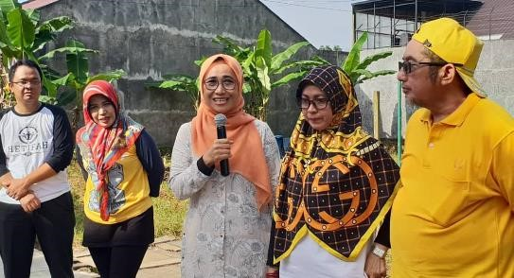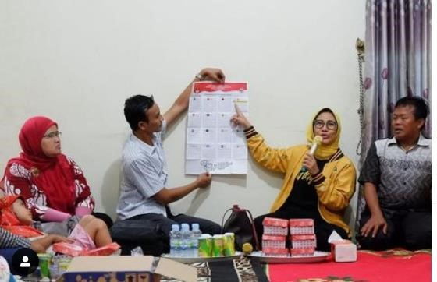

Figure 1 Hetifah’s survey Figure 2 Hetifah’s survey

Hetifah is also active in socializing regarding matters that are the needs of residents and specific communities. Hetifah socialized the development of clean water technology on Friday, 30 November 2018, in Muara Siran Village, Muara Kaman District, Kutai Kartanegara.
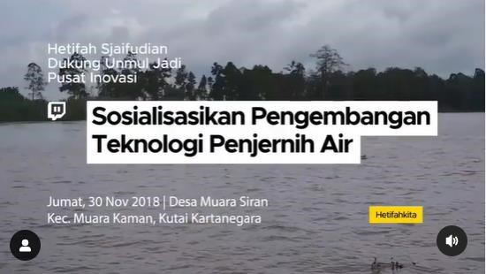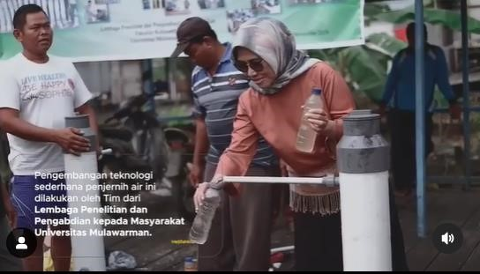
Figure 3 Hetifah’s Socialization Figure 4 Hetifah’s Socialization
It was also reinforced by the second informant, a campaign team for Hetifah, namely Luay Ali, who added information that when conducting market research, they also used the sampling method.
“We sampled and proportioned it according to the population in the district and city, and then we used multi-start random sampling.”
The third informant, also from the Campaign Team, Nana Nuzul Husna said that in the framework of the market research stage, they also used the community telephone method.
“We also use a telephone survey with the community. We also go door to door with the community.”
Stage 2: Product Design
Furthermore, after conducting research/surveys and having collected data and information on the wants and needs of the people or regions in the electoral area, the next step is to do product design. This step is where political parties or candidates adapt to the market and design products.
“..of course, after field observations have been carried out, then also communication with the community, then around the first three weeks what is done is mapping, especially related to regional conditions and the conditions of the constituency. “
For the implementation to run in a controlled manner, it usually goes through four stages: pre-design, design, execution, and monev (monitoring and evaluation). In the pre-design stage, political marketers conduct market analysis and STP (Segmenting, Targeting, and Positioning). At the design stage, designing political products designs the promotion mix of political (IMC). At the execution stage, all political marketers carry out all the activities that have been designed. Furthermore, at the Monev stage, a work assessment is carried out.
In order for a robust political identity or brand, there are criteria for the success of a brand, according to Needham, namely:
- Brands or identities describe something simple, so voters do not need to dig up detailed information about the products offered.
- The brand or identity must be unique and differentiated from competitors or competitors.
- Brands convince voters or thus increase voter confidence and reduce risks for product owners/political actors. d. Brands are aspirational and evoke a positive vision of a better destination.
- The brand symbolizes better internal values ​​of the product or organization than competitors.
- Brands will be considered credible and represent the value of the products offered
Stage 3: Product Customization
In this third stage, the product is adjusted based on several factors, such as the ability to fulfill promises, parties’ responses, analysis of competition with other parties, and analysis of which groups will be the key supporters of their ideas. Then, the parties develop products by considering the following:
- Achievability: ensuring promises are realistic, and the party team can fulfill them;
- Internal reaction: ensuring the change will attract sufficient support from MPs and members to ensure implementation, taking into account party ideology and history, maintaining specific policies to suit traditional supporting markets, and also creating a product that is different from competitors’ products;
- Competition: that it identifies the weaknesses of the opposition and highlights its strengths accordingly; is typical; and in multipart systems, it will also seek cooperation with the right potential partners;
- Support: developing targeted aspects of the product to suit the target market segment. At this stage,
Hetifah and the campaign team made adjustments to political products according to research results and did not harm the ideology of Hetifah herself or even the party. A set of adjustments to political products is carried out. They will be conveyed to the public during the campaign. Hetifah also said that adjusting political products to conform to ideology is natural.
“.. competition in elections and the contestation of ideas every day must be there, especially if we have assessed it in the DPR.. whether this law is necessary or not. Yes, frequently we also have to listen to the opinions of other parties, so there is a process which means it is not impossible that decisions are taken in politics which may not completely make us happy but also not completely defeat us.”
Apart from program design, no less important, according to Niffenegger in Firmanzah (2012: 202), is the candidate’s record, which can affect the number of votes. Luay Ali, as part of Hetifah’s campaign team, said that in the initial process of Hetifah entering political contention in 2009, Hetifah already had a good record in the hearts of the people, where Hetifa was considered a motherly and also humble figure.
“At the beginning of the election, we always show the figure of motherhood. The second is that she is also a woman. The most important thing is that this Hetifa is the servant of the person, that is what is being sold, and that is her ultimate weapon, miss. The others are just supporters, miss.”
From these records, Pak Luay Ali also said that from period to period, the votes tended to continue to increase because the public had seen what Hetifas had done.
“So the Hetifa’s vote tended to increase in 2009, the Hetifa’s vote was 23,000, in 2014 it was 48,000, in 20019 it was around 70,000 votes.”
In a product, according to Niffenegger in Firmanzah (2012: 202), what is no less critical is personal characteristics, namely regarding the image of the candidate in society. This statement was reiterated by Nana, who was also part of Hetifah’s campaign team in 2009 for the first period of Hetifah’s career in politics. She has been a member of the Indonesian parliament for three periods.
“The figure of an individual who is motherly, apart from that, she is also brilliant, so East Kalimantan is lucky to have her. Her concern for the community and the region is greater than that native person. Furthermore, you also know what to do. For example, each district/city has problems in detail, what are the concrete policies that must be implemented, you know, it is like a strength that might become something that people value as well.”
Stage 4: Implementation
In this fourth stage, namely the party/candidate implementation stage, implementing party/candidate orientation based on the market at each internal level. Implementation is the whole activity or process of ideas that have been prepared with great care and detail. Strategy implementation is a process where several strategies and policies are turned into action through the development of programs, budgets, and procedures. Although implementation is usually only considered after the strategy is formulated, implementation is the key to the success of strategic management. Strategy formulation and strategy implementation must be viewed from the currency side. (Mayastuti, 2018: 94). The implementation stages are certainly easier to see in the process of nominating Hetifah for the 2019-2024 period because she has carried out two terms in previous years. Hetifah also emphasized that the influence of the previous two periods made it easier for them to convey the implementation of what they had done from the previous period.
“In 2009, we worked fast, right, but in 2009, when we reached 2014, when our work was done, it would automatically become part of our branding.
In this case, Hetifah said that from the previous two periods, she also gained public sympathy with her performance and work programs, namely the provision of PIP/scholarships. The work program for awarding this scholarship is a continuous work program until 2019-2024.
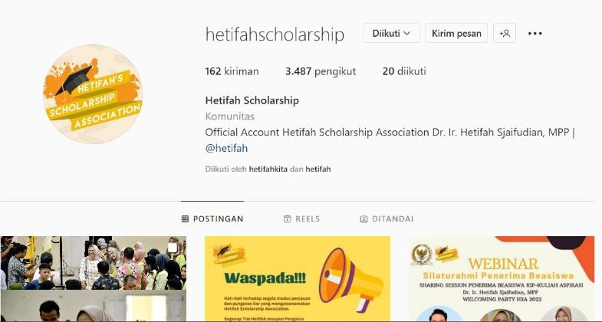
Figure 5 Hetifah’s Scholarship Instagram account
When she was on commission two, dealing with politics and regional development, Hetifah was also one of the figures who succeeded in fighting for it. Furthermore, this is undoubtedly an excellent view to shape the image of Hetifah.
“Yes, of course, we also have several things that are very special, and it is like division only happens once... but that is historic and has its value, and it is also proven that someone wrote a book about it, and there is also recognition from figures.”
As the success team for Hetifah, Nana said that every inspiration and need from the community tries to be voiced to related parties directly related to the policy needs. Not only voice but also provide real escort so that the presence of Hetifah truly represents the community as the people’s representative.
“So if, for example, someone has a problem, maybe the road is destroyed or what we voiced to the Ministry of Public Works and Public Housing but voiced it really, so it is guarded.”
Stage 5 Communication
At this stage, it is the momentum for the party/candidate to communicate to voters that they have designed a political product or, in this case, a work program according to the voters’ wishes. Of course, communication is carefully regulated so that the public can receive this information correctly. In this case, Hetifah said that it is necessary to communicate to the people who chose us that we have done what they need, and we have voiced it to the relevant parties to provide solutions to community problems jointly
“...I also know how to do it, but if we have images in now, we will publish images in every way, and there we will tell what has been done or is being done, so what kind of product is there so that people can check our work.”
Nana, the success team for Hetifa, also added information that they voiced what the community needs after surveying during the pre-campaign period.
“Basically, during our campaign, we never promised anything, but we conveyed what the problem of the people was so that we would voice it, but we never dared to make promises because promises are things beyond our control. So if, for example, someone has a problem, maybe the road is destroyed or what we voiced to the Ministry of Public Works and Public Housing but voiced it really, so it is being escorted.”
Stage 6 Campaign
At this stage, the official campaign stage is before the election. The party reminds voters of its products’ key aspects and advantages with effective organization and management, utilizes effective communication techniques and conveys positive and effective products to voters. In this stage, the researcher looked at the campaign used by Hetifah and her team following Firmanzah’s opinion in Latty Aziz (2007: 136), which mentions campaigns leading up to elections (short-term) and long term permanent campaigns (long-term). Of course, this is important to give a good image to society which has an impact on the sustainability of the candidate’s political image so that Hetifah can win three consecutive ter. In this case, Hetifah revealed that they immediately went down to the community during the campaign period, met with the community, and socialized directly. However, they also used other media, such as placing billboards and banners in residents’ homes along the main roads and also utilizing social media as a campaign medium namely, Hetifa herself has several social media accounts, Facebook, Instagram, Twitter, and Youtube, as expressed by Hetifah below.
“Starting from 2009, right.. because we had only a few months before the election.. after the first three weeks of the survey. I also remember that time too, did we also look for an inexpensive way, namely by making banners”
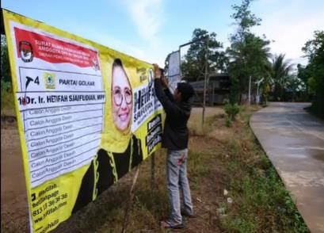
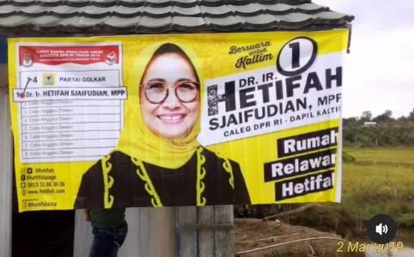 Figure 6 Installation of Hetifa Campaign Banners Figure 7 Installation of Hetifa Campaign Banners

According to Hetifah, installing campaign banners on the streets, markets, and even in residents’ homes is an effective campaign strategy because the capital is cheap, and the residents can see it quickly. Nana also corroborated this information as her team member provided information during the 2019 campaign. It was easier because, during the previous period, Hetifah was secured as a member of the Republic of Indonesia DPR RI over time, when Hetifah carried out her work in the previous period automatically became a platform for campaigning, Hetifah is also 2019-2024 period.
“Because Hetifah has had two previous terms in the 2019 candidacy, sis, we no longer need much campaigning time because the community has also seen your performance.”
Luay Ali also emphasized it as Hetifah’s team member for 2019-2024.
“pada tahun 2019 itu kami hanya 3 bulan sih kampanye, desember itu udah, terus kalau yang pertemuan-pertemuan itu biasanya waktu Ibu menjabat sebagai anggota, atau saat reses”
As for using social media as a media campaign, Nana emphasized that they use several social media because of their view that social media has its devotees.
“Yes, using Facebook and Instagram. We also have a website. Each of these media also has a different target audience, like Instagram, for example, it is mostly used by young people, while older people use Facebook.”
Apart from going directly to meet with residents to hold hospitality and outreach, Hetifah also makes social media one of the effective media for her campaigning. For example, she has an Instagram social media account named @hetifah, a Facebook account with the name Hetifah Sjaifudian, an account on Twitter with the name @hetfah1, and he also has a social media YouTube, namely with the account name Hetifah Sjaifudian. From this social media account, he actively shares information about his performance so that people can see his performance on their social media accounts.
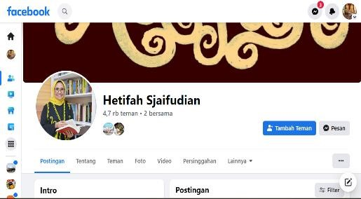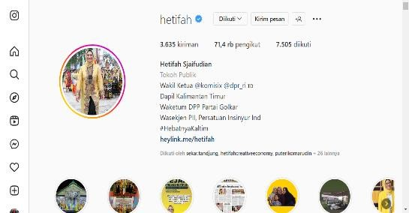
Figure 6 of Hetifah’s Facebook account Figure 7 of Hetifah’s Instagram account
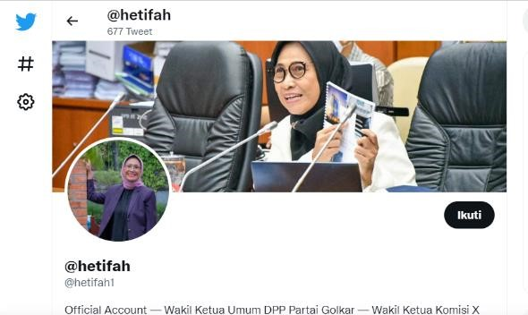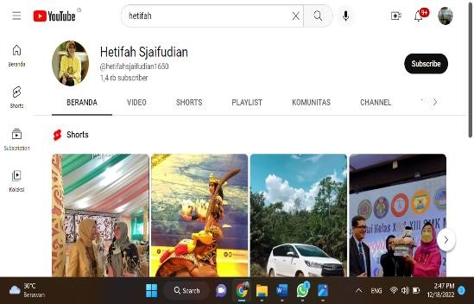 Figure 8 of Hetifah’s Twitter account Figure 9 of Hetifah’s YouTube account.

Stretching the use of social media is nothing new in Indonesia. Since experiencing a boom in 2012, people’s attachment to social media has increased. Social media, originally only used as a medium for socializing with friends and close relatives, are now starting to penetrate communication between individuals and institutions. With this phenomenon, political parties and candidates are starting to look at social media as a tool to interact with their constituents, including promoting their products. Ahead of the Legislative Elections, Political Parties have begun to create accounts to campaign for their parties and candidates intensively. The power of social media to influence society is based exclusively on its social aspects. Of course, it makes it easier for political candidates or parties to interact with the public and convey the interests of their candidacy in the intended agency. Not only personal accounts, the community, especially young people who took the initiative to become organic volunteers for Hetifah, also created an Instagram media account @hetifahkita to share information related to Hetifah and also the work programs carried out by Hetifah.

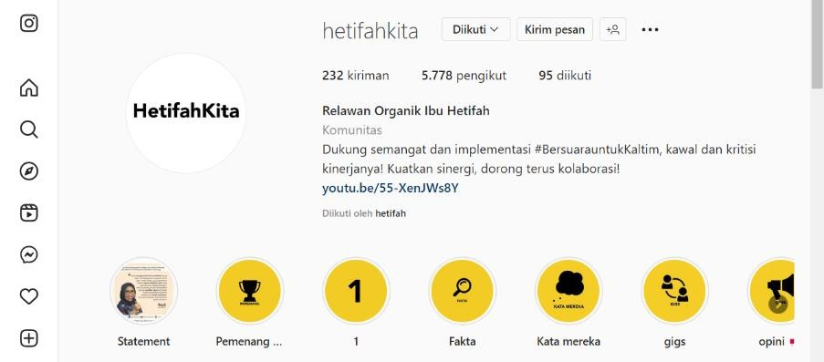
Figure 10 Volunteer Instagram account for Hetifah

Stage 7: Implementation of Elections
At this stage, namely the stage of implementing party/candidate elections, it must win votes and attract positive perceptions from voters in all aspects of behavior, including policies, leaders, party unity, and capabilities, as well as improve the quality of its membership. This election stage determines whether victory can be achieved or not. Of course, at this stage of the election, many things need to be considered, such as securing votes from fraud and monitoring during the direct election process, the vote counting process up to the determination of the vote results. Of course, this needs a particular escort. Pak Luay Ali also conveyed that they had formed a regional coordinator who served as an observer, and for TPS supervisors, he stated that a party had been provided.
“The Party has provided TPS supervisors, and if there is a district/city coordinator, ma’am.”
Stage 8: Delivery
At this stage, the party or political candidate realizes the party’s goals according to the promises made during the campaign. The party then needs to ship its products after the election. For the major parties to win elections, they must keep their word and communicate progress or engage in careful media management. Smaller parties or oppositions will be judged in terms of their objectives, such as their ability to get issues onto the agenda, or in a multi-party system, to work in coalitions, or to provide the opposition and effective representation.
Stage 9: Maintaining Market Orientation
From working visits to the electoral districts and implementing or implementing work programs, the steps taken by Hetifah are to continue to maintain market orientation. Political candidates or actors must maximize their potential to maintain support for repositioning policies and image-building to respond to changing constituent needs and aspirations. Another strategy for keeping political products moving is through research, inspection, and enforcement, considering the product life cycle. In business, it can be said that the development of each product has a specific time limit. For example, the only product that dominates the market and a new product must increase in quality until a new or better product is produced, subject to changes in market demand.
In general, the political marketing communication strategy of Hetifah Sjaifudian and her Winning Team in the 2014 election in East Kalimantan is to use approaches to the community. It is by knowing what the people need, then will be something they will voice at The campaign period follows the MOP (Market Oriented Party) method of conducting preliminary research to find out what the community wants as voters before they design the product. During the candidacy period for the 2019-2018 period, Hetifah Sjaifudian’s track record when she was a member of the RI DPRD for the two previous periods became a strategy in political marketing for Hetifah Sjaifudian in occupying a seat in the DPR RI in the 2014-2019 period.
Of the nine stages of the Market Oriented Party (MOP) political marketing strategy used by Hetifa Sjaifudian, the most impactful was the first stage of the market survey, which she carried out directly to the community, listening directly to the people’s aspirations. Then the second is the campaign stage, which is still in sync with the market survey stage. During the campaign, Hetifah went directly to the community to the people in areas that were difficult to reach. At that moment, she conveyed the political products designed according to the survey results to the community. The use of social media is also a separate segmentation for voters according to the elements of society. So that in this campaign, he can convince the public that he can bring the aspirations of the people later as a member of the DPR RI.
Next is the implementation stage, in the legislative nomination for the 2019-2024 period. Of course, this implementation stage has been running for the previous two periods to become good branding seen by the public that Hetifah is indeed working for the community with the implementation of the work program in the previous period. It is undoubtedly a good supplement for the community to trust Hetifah again to be elected as a member of the DPR-RI. Period 2019-2024.
CONCLUSION
This study concludes that Hetifah and her successful team in the 2019-2024 legislative election have carried out political marketing strategy activities that are carried out continuously from the 2009 legislative election campaign period to entering three periods in the 2019-2024 legislative election campaign. Applying a market-oriented party (MOP) political marketing approach was able to direct Hetifah and her team to understand the community’s needs. It became a strategy in political marketing for Hetifa and her success team in winning a seat in the parliament. The Hetifa’s incumbent status for two consecutive periods influences the public’s decision to elect Hetifah in the candidacy for the 2019-2024 DPR R members. The public had seen the performance of Hetifah during the previous two periods, and Hetifah was also well-known among the public. In her candidacy process, she participated in the market-oriented party (MOP) stage, starting at the political product design stage. Hetifah tried to design political products following the survey results going directly to the community. Her character, who is motherly, cheerful, and also smart, exudes the charisma of Hetifah that she can become a quality female leader.

BIBLIOGRAPHY
Alfian M Alfan, (2018), Wawasan Kepemimpinan Politik
Almini, Almini (2017) Strategi Komunikasi Pemasaran Politik Zainudin Amali Dalam Memenangi Pemilihan Legislatif Tahun 2014 Daerah Pemilihan Madura Jawa Timur Xi. S2 Thesis, Universitas Mecu Buana Jakarta.
Alwasilah, Chaedar A. 2002. Pokok Kualitatif: Dasar-dasar Merancang dan Melakukan Penelitian Kualitatif. PT. Dunia Pustaka Jaya. Bandung.
Arifin, Anwar. Komunikasi 2011. Politik. Filsafat-Paradigma-Teori-Strategi idan Komunikasi iPolitik iIndonesia. iGraha iIlmu.
Arnoldus Dillon Hastomo, Muhammad Aras Analisis Strategi Komunikasi Pemasaran Politik Hary Tanoesoedibjo (Studi Kasus Program UMKM sebagai Political Branding Partai Persatuan Indonesia (Perindo) E-ISSN: 2113-9790 Jurnal Prosiding Konferensi Nasional Komunikasi, Vol. 01, No.01, 2017
Basari, Rambang, Yulianita, Neni, Elizabeth Ayuna, Novianty. Strategi Komunikasi Pemasaran Politik H. Epyardi Asda, M.Mar Dan Jon Firman Pandu Pada Pilkada Kabupaten Solok 2020 Jurnal Akrab Juara, [S.l.], v. 6, n. 4, p. 82-92, nov. 2021. ISSN 2620-9861. Available at:. Date accessed: 30 june 2022.
Elfi Yanti Ritonga, Syukur Kholil, Hasan Sazali Communication Design of Bureaccratic Organizations in Gender Perspective in the Government of South Tapanuli District, Budapest International Research and Critics Institute-Journal (BIRCI-Journal) Volume 4
Ellaine Bingarrayni,Nur Kholisoh, Political Marketing Communication Strategy of Prabowo-Sandiaga in the 2019 Presidential Elections, Jurnal MICOSS 2020, September 28-29, Jakarta, Indonesia Copyright © 2021 EAI DOI 10.4108/eai.28-9-2020.2307722
Evi Sakdiah, Hasrat Efendi Samosir, Zainun, Anang Anas Azhar Budapest Forms of Mothers' Political Communication Participation in Improving Women's Political Roles in the 2019 Presidential Election in Medan City Internationale-ISSN: 2615-3076(Online), p-ISSN: 2615-1715(Print)
Firmanzah. 2010. Persaingan, Legitimasi, Kekuasaan, dan Marketing Politik : Pembelajaran Politik Pemilu 2009. Jakarta : Yayasan Obor Indonesia.
Firmanzah. 2012, Marketing Politik Antara Pemahaman dan Realitas. Yayasan Obor Indonesia. Jakarta.
Hikmat Mahi M. Komunikasi Politik, teori dan praktik dalam pilkada lamgsung. Simbiosa Rekatama Media
Less-Marhsment Jennife, 2009, Global Political Marketing
Marshment, Jennifer Lees, 2003. Political Marketing : How to Reach That Pot of Gold. Journal Of Political Marketing. Volume 2, Issue 1 PP: 1-32.
Moleong, L.J. 2010. Metode Penelitian Kualitatif. Bandung: Remaja Rosda Karya . 2007. Metode Penelitian Kualitatif. Bandung: Remaja Rosda Karya . 2006. Metode Penelitian Kualitatif. Bandung: Remaja Rosda Karya
Nanjing Normal University, Wenyuan Road Qixia District, Nanjing 210046, Communication Strategy To Improve Women's Political Participation In Indonesia P.R. China International Journal of Communication and Society ISSN 2684-9267 Vol. 1, No. 2, December 2019, pp. 68-81
Nita Ria Liliana Strategi Komunikasi Pemasaran Politik dalam Kampanye Calon Legislatif (Caleg) Terpilih Partai Persatuan Pembangunan (Ppp) dalam Pemenangan Pileg 2014 Kota Pekanbaru scription Journal article public Jurnal Online Mahasiswa Fakultas Ilmu Sosial dan Ilmu Politik Universitas Riau JOM FISIP Vol. 2 No. 2 Oktober 2015
Nurfitriani,Hamrun, dan Ahmad Taufik Pemasaran Politik Bupati Bima Terpilih pada Pilkada Kabupaten Bima Tahun 2015 Jurnal Ilmu Pemerintahan dan Sosial Politik UMA, 5 (2) (2017): 71-78
Pratama, Arie Ade (2020) Marketing Politik: Pemenangan Indra Utama Pada Pileg Dprd Kabupaten Bengkulu Tengah 2019. S2 Thesis, Universitas Mercu Buana Jakarta. Tesis
Primus Adeodatur Latu Batara, Guntur Freddy Prisanto, Niken Febrina Ernungtyas, Irwansyah Safira Hasna Strategi Komunikasi Pemasaran Politik Pada Pemilu Legislatif Journal of Communication Studies Vol 5 No 2 September 2020 E-ISSN: 2549 693X P-ISSN : 2356-4490
Rosa Arista Narendra Strategi Komunikasi Politik Pasangan Bambang-Icek Dalam Pemilihan Umum Kepala Daerah Kabupaten Grobogan Tahun 2011 Politika: Jurnal Ilmu Politik, vol. 3, no. 1, pp. 33-46, May. 2013.
Runkito, Herman. 2014. “Strategi Komunikasi Politik Partai Gerindra Dalam Pemilu 2014”. Tesis Pascaserjana. Universitas Mercu Buana. Jakarta. Scammell, Margaret. 2015. Political and Image: The Conseptual Value of Branding.Jurnal Political Marketing, Vol.14, No,1, pp: 7-18.
Speed. Richard., Patrick Butler., dan Neil Collins. 2015. Human Branding in Political Marketing: Applying Contemporary Branding Thought to Political Parties and Their Leaders. Jurnal Political Marketing, Vol.14, Issue,1, pp:129-151.
Suryani, Septiar Andrilaransyah Komunikasi Pemasaran Politik Dalam Pemenangan Pilkada Kabupaten Bangka Periode 2018-2023 Jurnal Ilmu Komunikasi (fisip upm Jawa Timur):Vol. 3 No. 2 (2020)
Thompson. L John, 2001, Understanding Corpo-rate Strategy, Cengage Learning EMEA.
Uspal Jandevi Communication Strategy To Improve Women's Political Participation In Indonesia International Journal of Communication and Society ISSN 2684-9267 Vol. 1, No. 2, December 2019, pp. 68-81
Waluyo Handoko Isu Perempuan Sebagai Strategi Komunikasi Politik Kampanye Calon Dalam Pilkada : Jurnal Studi Islam Gender Dan Anak, 4(2),213-221.Retrievedfrom https://ejournal.uinsaizu.ac.id/index.php/yinyang/article/view/230 Vol 4 No.2 (2019)
Wijaya, Bambang Sukma Perang Tema dan Psikologi Publik: Analisis Strategi Komunikasi Pemasaran Politik Pilkada DKI Jakarta 2007 (2012) . Jurnal Komunikologi, Vol.09 (02). pp. 83-88. ISSN 1907-8870
Yuyun Zunaria, Poppy Ruliana Model Orientasi Pemasaran Politik sebagai Strategi Komunikasi Pemenangan Pemilu Legislatif Jurnal Warta Ikatan Sarjana Komunikasi Indonesia e-ISSN: 2686-0724 - p-ISSN: 0853-4470 - Vol. 5, No. 01 (2022), pp. 81-91

