MEDIUM ANALYSIS OF SATIRE AND SOCIAL CRITICISM IN KOMPAS TV'S INDONESIA STAND UP COMEDY SHOWS: EPISODE OF ERNEST PRAKASA (MY BELOVED WIFE)

Veronika Ita Karina Tarigan
Communication Science Lecturer of Bunda Mulia University
itainoe@gmail.com, pkinasih@bundamulia.ac.id

ABSTRACT

Background
All human beings definitely want to be happy. All people in the world, including Indonesian people, have the right to be happy, one of which is by listening to funny and humorous stories. Well, Indonesia is a very rich country with humor. Indonesia itself has many traditions and traditional figures who often joke or give jokes about things that happen around the community. In recent years, jokes have developed in various events, one of which is Stand Up Comedy, which does not only appear in closed-room events, and is now increasingly successful in On Air activities at a number of television stations. In this journal, researcher is search data by interviewing the Executive Producer of StandUp Comedy Kompas TV, comedy scriptwriters and making a number of observations. That way researchers get results and know the communication strategy of StandUp Comedy community in maintaining its existence.

Methods
This study aims to find out what are the contents of messages contained in the text of the comic material, with a qualitative approach using the Ferdinand De Saussure method of semiotic analysis. The formulation of problem in this study is to examine message contained in the StandUp Comedy comic material and its effect on many people if it is broadcast on electronic media, especially television media. Considering that this approach and type of research uses qualitative content analysis, the meaning of this method is an integrative and more conceptual analytical method to find, identify, process and analyze documents or texts in order to understand their meaning, significance and relevance.

Results
Stand Up Comedy performances are not just entertainment, but can also act as a didactic medium because the information or conveyed contains informative and educational messages for the audience. Stand Up Comedy performances are also expected to be a tool for social criticism for a person, a group of people, a certain community, which sometimes often forgets the essence that is important in society.

Conclusions

The results of this study indicate that Standup comedy community is able to maintain the existence of comics by communicating with audience. The more showtimes of new comedians, the more they will train each comic's sense of humour so that they are able to make a show with mature material. It is hoped that Stand Up Comedy competition activities carried out by comic artists at the Kompas TV Studio will continue to develop until finally 1st and 2nd place winners are won in the event. Outside the Kompas TV event, it is hoped that the comic winners or finalists will continue to communicate externally, such as participating in competitions by becoming judges for StandUp Comedy, gigs, jobs, Stand Up comedy community gatherings, working with other organizations and even holding Stand Up comedy goes to school in search of new seeds.

Keywords: Comedy, Communication Message, Social Criticism.

Introduction
Background of the problem

Humour is one of the human needs that is difficult to avoid. As a non-material need, humour will have a big effect on the audience. Every individual and even a group of people are often humorous, either intentionally or unintentionally. Humour is usually done intentionally in front of a large crowd, for example in a ludruk, ketoprak performance, or in a speech in order for breaking the ice. Humour is inadvertently caused by circumstances that suddenly arise and make those around them laugh.

Everyone has their own way of conveying wishes, feelings and even a political message. In a book entitled Political Communication in the Digital Era authored by Silvanus Alvin, S. I. Kom., MA, states that anyone can carry out political communication. Political communication is not an exclusive right that only politicians have. An ordinary citizen can also carry out political communication, when he has political intentions and goals to be achieved. In addition to political communication, communication activities can also take place through humour. Humour is a way to convey something indirectly. This is what makes humour something interesting in society. Humour is a means of communication, such as conveying information, expressing pleasure, anger, annoyance, or sympathy. In addition to its function to change a person's emotional situation, humour also has a function as a means of education and social criticism. As an educational tool, humour is used by the public as a tool to increase knowledge and insight. As a means of social criticism, humour is a powerful tool of criticism because those who are criticized do not assume it as a confrontation. Currently, one channel that is felt to be growing in the community is Stand Up Comedy. Stand Up Comedy is a one-man show comedy genre that performs a humorous monologue and provides personal observations, opinions or experiences. Expressing anxiety, highlighting reality, photographing people's social life, and presenting it back to the community in a humorous way. Stand up itself means not standing up, but rather expressing and defending one's opinions and views. Stand Up Comedy is story-based comedy that raises common themes that are humorous based on someone's point of view. Stand Up comedy requires a lot of references as a joke material. We can capture the patterns of human culture, including patterns of thinking, through their narratives, anecdotes, proverbs and humour (Prof. Deddy Mulyana, 2021).

When a person feels amused, uncomfortable, or strange about a certain thing, comedians will turn them into a smart comedy. Unlike the types of jokes and humour that are common in Indonesia, Stand Up Comedy is a new thing and trending among young Indonesians. Where previously Indonesian comedy prioritized physical comedy and slapstick, puns and pantun humour. According to Nur Hidayat, an education practitioner who is also one of the writers of comedy scripts for the comedy group Patrio which had boomed at TPI in the 1990, stating that appearing in public or society to present comedy content is not easy. It's not just about appearing and appearing ridiculous, but there must be content that has been prepared in detail in advance, individually or per group or groups. Apart from that, there are several parts or frames that have been taken into account so that you understand when to start the opening, the core of the story, the climax of the story until the closing. All of that must be done properly otherwise, because of the possibility that the story will be stale and will not make the audience laugh, it will happen.

In country areas, jokes are often delivered by village leaders in various events or occasions such as circumcision events, weddings, village events or health counselling activities. Then what about in urban areas? Almost the same as in country areas, activity of joking or throwing jokes can be enjoyed by most of the audience through various activities, one of which is Stand Up Comedy, which in recent years has become a new trend in Indonesia. Initially StandUp Comedy programs could be enjoyed in special events in closed rooms or special events, but now StandUp Comedy can be enjoyed widely throughout Indonesia because it is broadcast live or directly, or even broadcast reruns (rebroadcast) because stand-up comedy activities are now being held on various television stations in Indonesia. In his journal and book entitled Portrait of Stand-up Comedy: Strategies for Becoming a Reliable Comedian, Pandji Pragiwaksono explained that Stand Up Comedy community in the regions has grown more rapidly in the last ten years, from Aceh to Papua. What's interesting is that each region has a unique comedy culture, like Papua, which has a unique humour called mop or mob. The potential for single comedy in each region basically already exists plus the presence of various parties who help sharpen this raw talent into a sharp standup comedy show.

Stand Up Comedy is a form of comedy that is presented to the audience live. Usually comedians do one man shows, throwing jokes through monologues or statements in one sentence that contain humour. Comedians in this line usually write their comedy scripts to appear in 20-45 minutes. Structured technique and preparation are absolutely necessary before acting on stage. Therefore, the most important thing in public speaking is self-awareness. selfaware. What potential and constraints exist within yourself (Ayu Kartika Sastrosusilo, 2020). Sometimes comedians use props to convey their jokes. Even though it's called stand-up comedy, comedians don't always stand up to deliver their comedy. Some comedians do it by sitting in a chair just like a person tell story. These performers or comedians are usually called stand-up comics or briefly called comics or in Indonesia they are known as comics.

The history of stand-up comedy began in the 18th century in Europe and America. Historically, the development of stand-up comedy has also been found in various continents. In the United States, stand-up comedy has been around for a long time. Some say it has existed since the 18th century. Growing in the 1960's. Several famous foreign comics include Jerry Seinfield, Eddie Izzard, Akmal Saleh, Daniel Tosh, and others. In Hollywood, famous actors such as Woody Allen, Rowan Atkinson, Chris Rock, Will Ferrell and Jim Carrey have struggled in this field. The

Hollywood star started his career in the world of stand-up comedy before being known as what he is today. Around the 1800s in America, at that time, for the first time, it was still in the form of theatre. These theatres were often built on the side of the road in order to give entertainment to people around it.They usually entertainmented them with funny stories in several episodes. Long ago in America there was a theatre called The Minstrel Show which was hosted by Thomas Dartmouth "Daddy" Rice.

At that time Mic had not yet been born, the comics used Slapstick or better known today as physical jokes. Even so, this event was able to survive into the 20th century. A new solo comedy known as stand-up comedy and the comedians called comics actually only started in 1966 which was put forward by people from the University of Oxford. Indonesia itself in the development of stand-up comedy has started with the figure of Ernest Prakasa. His name began to be known as a solo comedian since he won third place in the StandUp Comedy program in 2011. Ernest entered Indonesian film industry as an actor, then developed into a director and screenwriter. This event immediately received a response from Indonesian society, so it can be said that the event immediately boomed. Ernest Prakasa is one of five influential figures in the development of StandUp Comedy in Indonesia, namely Ernest Prakasa, Ryan Adriandhy, Radika Dika, Pandji Pragiwaksono and Isman H. Suryaman. They are the people who play a role in making stand-up comedy so popular today. The open mic they did at the Comedy Café on 13 July 2011 was uploaded to YouTube and received an extraordinary response. This momentum was then read by Metro TV and Kompas TV.

Since then, Stand Up Comedy communities have sprung up all over the archipelago under the name Stand Up Indonesia or abbreviated as StandUp Indo. Come up with StandUp Comedy Show & Battle of Comic on Metro TV. This event started on September 22, 2011. The format of the StandUp Comedy Show is where the comics who is invited that day are called up on stage and then have a monologue on a topic with jokes based on the characteristics of each comic and after all the comics have finished, judgment will be made based on the applause of the audience, while Battle of Comic has a format where the comics are given the theme provided that day and each comic must process the theme into a joke with a set time. At that time, Stand Up Comedy had captivated heart of Indonesian youth, therefore Kompas TV held a stand-up comedy competition under the name Stand Up Comedy Indonesia (SUCI). Stand Up Comedy event, which was originally only enjoyed when performing at an indoor off-air event, is now able to rise in caste by coming up with comedy on a big stage with an enormous audience which is broadcast live throughout Indonesia with the help of Broadcasting technology. Dwi Ananto Widjojo explained in his book entitled Television Transmitters and Studio Equipment, the ability to transmit information or an event is now made easier by the increasingly sophisticated developments in television broadcasting technology.

Identification of problems

From the description of the background of the problem above, it can be seen that several points are interrelated between the current virality of StandUp Comedy activities and the presence of the current television media. So that the topic of research can emphasize several factors:

- A measure of how viral and fun facts Stand Up Comedy is for its audience?

- Can important and humorous information be absorbed from any StandUp Comedy content, especially as social criticism?
- How far the communication strategy and preparation of a comic when he is about to come on stage?
- Analyse what is the motivation to become a comic?
- How to reveal the material so that the audience laughs with the material presented?

This event carries a competition format to find the best comic in Indonesia. Fina Merliane Vidya, Executive Producer of SUCI (Stand Up Comedy Indonesia) at Kompas TV, explained that the stage of organizing this competition began with holding auditions in big cities in Indonesia. The comics who pass the audition stage will come on stage in the general round in Jakarta. In the main round, the show is held once a week, with topics that have been prepared in advance by the committee. She even explained the event processed in her Instagram Stories and feed. During the quarantine period, each comic had to compose words and body gestures according to the theme within a week. Every week the judges will then eliminate one of the comics. The culmination of this main round leaves or produces two comics who fight in the final round to fight for champion status in this competition. Public interest in StandUp Comedy continues to increase, as evidenced by the increasing number of other programs with the theme of Stand Up Co

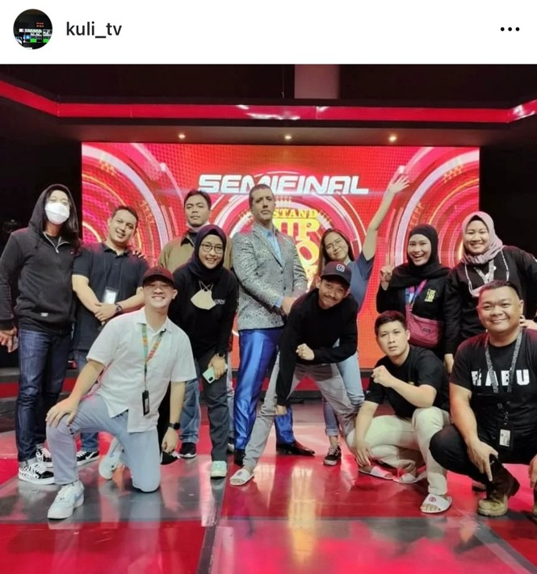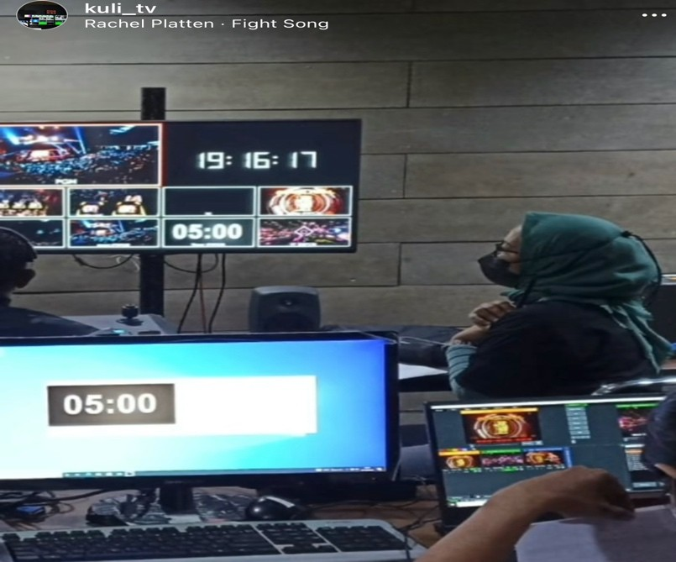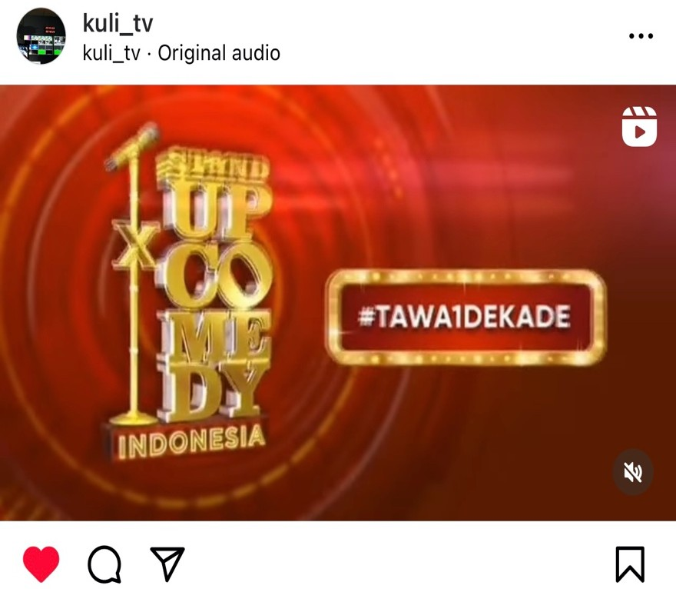

The television program is filled with various kinds of characters and comic backgrounds. Comic actively tells stories about the results of his experiences, observations and aspirations for the life around him which is packaged into something funny to the audience. Many of them carry their idealism while still presenting material that they have the theme of anxiety, but many of them use materials that only make the audience laugh. It's not uncommon for comics to combine both types of material in their performances. As previously explained, comedy in the form of stand-up comedy has also shifted a lot from its beginnings. Not many comics still carry anxiety in their material.

Referring to this as a verbal communication entity, speech in stand-up comedy cannot be separated from certain aims and objectives. The utterances conveyed by comics are essentially based on intent and purpose. Stand-up comedy shows are not just for entertainment, but can also act as a didactic medium because the information or material conveyed contains messages that can educate the audience. Here the researcher prefers to examine Indonesian Stand Up Comedy (SUCI) as a form that stand-up comedy is one of the media for conveying messages where from every material presented by comics there are messages which are then conveyed to the public as recipients of broad, anonymous, and heterogeneous, such as conveying information, expressing pleasure, anger, annoyance, or sympathy. The messages in the stand-up comedy are also conveyed quickly, simultaneously and easily understood, because some of the material conveyed by comics raises issues that are developing and often occur in society.

Based on background of the problem above, the researcher wants to know about the contents of Ernest's message in criticizing habits while expressing affection for his beloved wife contained in StandUp Comedy comic material. The writer also conducted research on SUCI 1 SHOW 6 on Kompas TV, then the researcher took the title "Analysis of Medium Satire and Social Criticism in Indonesian Stand Up Comedy Shows on Kompas TV: In Episodes of Ernerst Prakasa (My Beloved Wife)".

Research purposes:
Starting from the formulation of the problems and research questions mentioned earlier, this research was conducted with the aim of:
- Knowing the definition and assessment of why StandUp Comedy is considered a smart comedy style (Smart Comedy).
- Knowing which electronic media in Indonesia is most suitable for broadcasting Stand Up Comedy programs.
- Knowing each element and part of StandUp Comedy that is applied to a comic's communication strategy.
- Knowing updates, what social media to raise news or what cases are appropriate to be raised as current topics.

Theoretical Review

- The message is a set of verbal and/or nonverbal symbols that represent the feelings, values, ideas or intentions of the source. According to Onong Effendy, states that message is: "a component in the communication process in the form of a combination of someone's thoughts and feelings by using symbols, language/other symbols conveyed to others". While Abdul Hanafi explained that message was "a real fictitious product generated by the source-encoder". When speaking, the "speaker" is the message, when writing a letter, the "letter writing" is called the message. Messages have three components: meaning, the symbols used to convey meaning, and the form or organization of the message. The most important symbols are words (language), which can represent objects, ideas, and feelings, both speech (conversations, interviews, discussions, lectures, and so on) or writing (letters, essays, articles, novels, poems, pamphlets, and so on). Words, allow us to share thoughts with others. Messages can also be formulated nonverbally, such as through bodily actions or gestures.

- Message construction and ways of viewing. From the popular scientific dictionary, a construct is a conception, a form of arrangement. In the science of communication, the message is a meaning that a communicator wants to convey to the communicant. The message is meant to have a common intent between the communicator and the communicant. In communication, the message is a very important element. Communication process occurs because there is a message to be conveyed to others. The success of a stand upper is for viewers to understand the jokes or humour conveyed and laugh along with them. For that, stand upper skills are needed such as understanding basic comedy techniques, practicing gestures or body poses, having broad insight, understanding cases or issues that are being updated and prepare material for jokes in as much detail as possible.

Then what special strategies are needed in conveying a message or you could say a special art in storytelling. Delivering your first speech can be a nerve-wracking experience…but here are a few things to concentrate on your presentation. First of all, Starting your speech. When it is your turn to speak, move to the front of the room and face the audience. And then the second, Gesture. Whatever gestures you use should flow naturally from your feelings. Third, Eye Contact. During your talk, look at your classmates as often as you can. The Voice, try to use your voice as expressively as you would in normal conversation. The last one is, dealing with nerves. Keep in mind that while you may be anxious about giving your speech, usually your nervousness will not be visible to your audience. (Stephen E. Lucas, The Art of Public Speaking, McGraw-Hill New York Edition, page 68, 2020). After we understand how to tell stories so that listeners understand what we are conveying, we must be smart in packaging stories so that listeners understand "How to see the current issue or topic".

According to Eriyanto in his book Framing Analysis in 2012, basically framing is a method to see the media's way of telling an event. How to tell story is illustrated in the "how to see" the reality that is made into news. This "way of seeing" influences the end result of the construction of reality. Besides having to be smart to compose narrations or stories, a comic must also think about basic things in communicating. Message Construction Harold Lasswell in his work, The Structure and Function of Communication in Society, said that the best way to explain communication is to answer the following questions: Who Says What in Which Channel to Whom with What Effect? From this paradigm it can be seen the elements of communication such as communicators, messages, media, communicants, and effects.

Whatever the characteristics of your voice, you can be sure it is unique. Because no two people are exactly the same physically, no two people have identical voices…The aspects of voice you should work to control are volume, pitch, rate, pauses, vocal variety, pronunciation, articulation and dialect. (Stephen E. Lucas, The Art of Public Speaking, McGraw-Hill New York Edition, page 235, 2020). According to Ayu Kartika Sastrosusilo in her book Talk Before You Speak explaining that telling stories or humour is also not far from the concept of Public Speaking and several methods ranging from the impromptu or spontaneous method, the script or script method, the Extemporary method or outlining the framework and the Memorization Method (Memorization). The method that is often used by comedians in StandUp Comedy is the last method, namely the Memorization Method. They have previously prepared a frame of mind according to the designated theme starting from the opening, body, climax of the story to closing.

The message can be written or spoken, in which there are symbols that are meaningful and have been agreed upon between the communicators. Given the importance of messages in a communication process, messages should be produced properly so that the communicant can understand the contents of the message properly.

Content Analysis

Content analysis is a research technique for making replicable inferences, and correcting data by taking into account the context. Content analysis is related to communication or communication content. The basic logic in communication is that every communication always contains a message in its communication signal, both verbal and nonverbal. So far, the meaning of communication has become very dominant in every practical communication event in its implementation.

In the beginning, quantitative content analysis was indeed better known in research. The first known quantitative content analysis was research on newspapers. At that time the facts used in content analysis research had to be quantitative. Along with the development of electronic media, the realm of content analysis research then also penetrated into the fields of radio, film and television broadcasting. Furthermore, content analysis is now also used to research textbooks, comic series, speeches, and advertising.

Research methods

The research method or procedure to produce descriptive data directed at the background of the individual as a whole or holistically is called qualitative. This method is used by researchers in this study, while the type of research that researchers use is content analysis. Qualitative research data collection was carried out through several stages, namely:

  - Exploration stage or general observation;
  - Focused Exploration Stage;
  - Data collection stage;
  - Data confirmation stage.

This is stated in a book entitled Qualitative Research written by Prof. Dr. H. M. Burhan Bungin, S.Sos., M.Sc. The subject of this study was a video tape material and the object was the message content of StandUp Comedy Indonesia-SUCI 1 Season 6 material on Kompas TV, on February 6th, 2016.

Research Results and Discussion

The results of this study indicate that the messages obtained from the four stand-up comic comedy texts when viewed from the form of the message, the material presented by the comic is included in the informative message, because each material presented by the comic provides information on facts and data from their observations. Humour in stand-up comedy is different from other comedy genres, the strength of stand-up comedy lies in the use of verbal language which is very dominant. Comic actively tells stories about the results of his experiences, observations and aspirations for the life around him which is packaged into something funny for the audience.

Referring to this as a verbal communication entity, speech in stand-up comedy cannot be separated from certain aims and objectives. As in his book Leech Geoffrey "principles of pragmatics" states that in pragmatics, speaking is a goal-oriented activity. The utterances conveyed by comics are essentially based on certain aims and objectives which include various broad dimensions of meaning and intent. Stand Up comedy shows are not just for entertainment, but can also act as a didactic medium because the information or material conveyed contains informative and educational messages for the audience.

Conclusions

In this research, the focus of the study is the script from StandUp Comedy Indonesia SUCI 1 Season 6 on Kompas TV. This research is only looking for what message is contained in the stand- up comedy comic material. In the discussion, the results obtained that the message contained in the comic material manuscript is a critical message. And in terms of the form of the message, it is more informative, because the comic tells a story based on factual data about the problem being raised.

Stand Up Comedy is full of messages on social issues, one of which is a message of criticism. Through comedy media, one can criticize social problems or what is happening in society. Comedy allows people to criticize in a polite way, including the comic Ernest roasting his wife and children about their daily habits in a family but without making his wife angry or embarrassed. All the information that Ernest mentioned earlier actually made his wife laugh and be entertained. As smart entertainment, stand-up comedy also educates and persuades the audience to open their minds together and laugh at their surroundings and even themselves without having to be offended by the material presented.

BIBLIOGRAPHY

Eriyanto. (2002). Analisis Framing Konstruksi, Ideologi, dan Politik Media. Yogyakarta: LKiS.

Prof. Deddy Mulyana, M.A., Ph.D. (2021). Belajar Komunikasi Lewat Cerita dan Humor. Jakarta: PRENADA.
Silvanus Alvin, S.I.Kom., M.A. (2022). Buku Komunikasi Politik di Era Digital: dari Big Data, Influencer Relations & Kekuatan Selebriti, Hingga Politik Tawa. Sleman,Yogyakarta: Deepublish.
Stephen E.Lucas. (2020). The art of Public Speaking. New York: McGraw-Hill Edition. Ayu Kartika Sastrosusilo. (2020). Talk before you Speak. Jakarta: Buku Forum.
Cheyne, Mary. (2016). Present yourself in Public Speaking. NI: Penerbit Independen
Olivera Tesnohlidkova. (2020). Article Humor and satire in politics: Introducing cultural sociology to the field.
Prof. Dr. H. M. Burhan Bungin, S.Sos., M.Si. (2017). Penelitian Kualitatif, Komunikasi, Ekonomi, Kebijakan Publik, dan Ilmu Sosial lainnya. Depok: PT. RajaGrafindo Persada.

Panji Nugroho. (2012). Potret Stand Up Comedy: Strategi Menjadi Comedian Handal. Yogyakarta: Pustaka Baru Press.

Nora Azizah.(2022) https://republika.co.id/tag/stand-up-comedy (Diakses tanggal 02 Januari 2023, pukul 13.00).

Rodasaut.(2013) “Apa itu Stand-up Comedy?”. http://rodasaut.blogspot.com/2013/01/apa-itu stand-up-comedy.html (diakses tanggal 15 Desember 2022, pukul 16.00).

Dwi Arjanto.(2022). https://seleb.tempo.co/read/1527973/sejarah-lahirnya-stand-up-comedy- awalnya-berupa-teater ( Diakses tanggal 15 Desember 2022, pukul 16.00).

Dwi Ananto Widjojo.(2013). Pemancar Televisi dan Peralatan Studio. Bandung:ALFABETA.

Tri Adi Sarwoko. (2011). Sukses Melawak: Cara Jitu Mempersiapkan Kreatif Komedi. Sleman,Yogyakarta: Andi-Pustaka Kita.

